Management strategy evaluation of Pacific hake

Nis S. Jacobsen1, Kristin N. Marshall1, Aaron M. Berger2, Chris J. Grandin3, Ian G. Taylor1

*1Northwest Fisheries Science Center, National Marine Fisheries Service, National Oceanic and Atmospheric Administration, U.S. Department of Commerce. 2725 Montlake Blvd. East, Seattle, WA 98112-2097, USA*

*2Northwest Fisheries Science Center, National Marine Fisheries Service, National Oceanic and Atmospheric Administration, U.S. Department of Commerce, 2032 SE OSU Dr. Bldg. 955, Newport, OR 97365-5275, USA*

*3Pacific Biological Station, Fisheries and Oceans Canada, 3190 Hammond Bay Road, Nanaimo,B.C. V9T 6N7, Canada*

# To do

* Fix colors to be the same on all figures
* Discussion
* (verify figure order)
* Add plots of the spatial performance metrics
* Add text description of objectives and performance metrics (KM)

Contents

To do 1

Abstract 3

Introduction 3

History of the Pacific hake MSE 4

Pacific Hake MSE process 5

Phase 1 – Plan MSE 5

Phase 2 – Design MSE simulation 6

Phase 3 – Implement MSE simulation 7

Phase 4 – Presentation of MSE results 7

Use of MSE outcomes 8

Objectives and Performance Metrics 8

Description of the closed-loop simulation model 8

Operating model. 9

Equilibrium abundance 9

Initial conditions 9

Growth 10

Reproduction 10

Fishing 11

Movement 11

Catch 12

Data generation 12

Spatial assumptions in the two-box, four season model 13

Estimation model 13

Comparison of the TMB model with the current Pacific hake stock assessment model 14

Default management model 15

Conditioning the operating model 16

Management strategy evaluation scenarios 16

Alternative implementation scenarios 17

Climate scenarios 17

Selectivity scenarios 18

Survey frequency scenarios 18

Results 19

Conditioning the operating model 19

Discussion and perspectives 21

References 22

Figures and Tables 24

Glossary of Terms for Pacific Hake Management Strategy Evaluation 46

Keywords: Management strategy evaluation, stock assessment uncertainty, spatial distribution,

Pacific hake

# Abstract

A key question regarding management of exploited species is how spatial structure influences the estimation and derivation of management quantities. The Pacific hake stock migrates between Canadian and U.S. exclusive economic zones, and management is directed through a binational treaty, where quotas are based on a harvest control rule and a fixed allocation to each country. There are two pertinent hypotheses regarding how spatial structure of the stock can affect management: 1) demographic distribution shifts - Pacific hake spawn in the southern California Current (U.S. territory) and the extent of northward migration (towards and into Canadian territory) is related to individual size, and 2) climate-driven distribution shifts – prevailing ocean conditions, including climate change, cause distributional shifts of the stock. We use management strategy evaluation (MSE) as a framework to evaluate how alternative hypotheses about spatial stock structure influence robust management choices. The MSE employs closed-loop simulations with an operating model that represents the complexity of hake biology, an observation model that ‘samples’ data, an estimation model similar to the stock assessment model used for Pacific hake, and a management model that translates stock assessment outputs into total allowable catch. By explicitly modeling spatial structure (i.e., movement and spatial recruitment) in the operating model, we evaluate the accuracy and associated uncertainty of estimated reference points that do not account for spatial differences. The results of the MSE are contextualized in regards to improving current management and assessment of the binational stock.

# Introduction

Management strategy evaluation (MSE)is a structured decision-making process that evaluates the performance of alternative management actions in light of prespecified objectives. MSEs use simulation testing to evaluate the performance of potential management approaches in the face of uncertainty about current and future conditions. MSEs offer a flexible framework that can be used in support of diverse management needs, such as choosing a harvest control rule (e.g. Cox and Kronlund), or evaluating the long-term consequences of decisions about the structure of a stock assessment model (e.g. Wiedenmann) or the frequency of observation of a population (e.g., Hutzniak).

The degree of engagement with managers and stakeholders varies considerably across MSE applications. Some exercises focus extensively on the simulation modeling component. For example, identifying strengths and weaknesses of general types of assessment models or harvest control rules may be done without much outside input. MSE processes that are more linked to decision-making often benefit from broad stakeholder input. A manager and stakeholder driven MSE also creates an opportunity for adopting a transdisciplinary research model and promotes resource co-management. Transdisciplinary research integrates knowledge from scientific and societal bodies of knowledge, creating opportunities for mutual learning, and co-producing solution-oriented knowledge (Lang et al. 2012).

Most simulation testing frameworks used in MSEs share similar elements (Figure 1). They typically involve simulation models of an underlying population or biological system of interest (operating model), how it is observed and quantified by people (observation model and estimation model), and how decisions are made with respect to its management (management model).

## History of the Pacific hake MSE

Pacific hake (whiting) is the largest groundfish fishery on the Pacific West Coast, with over 300,000 tons annual catch in recent years. The US-Canada Agreement for the management of Pacific Hake was fully implemented in 2012 when the stock assessment was first conducted by the newly appointed Joint Technical Committee (JTC) and first reviewed by the newly formed Scientific Review Group (SRG). Both the JTC and SRG reports that year highly recommended embarking on a Management Strategy Evaluation (MSE) as a tool to explore a variety of issues associated with management of the hake fishery, including data collection (frequency of acoustic surveys), assessment methods (treatment of selectivity), and management (performance of the harvest control rule) (SRG, 2012; Stewart *et al.*, 2012).The Pacific Hake fishery had also been certified as sustainable by the Marine Stewardship Council in 2010 with the evaluation of the harvest control rule in an MSE framework included as a condition for maintaining the certification (Devitt *et al.*, 2009).

An MSE was first conducted during the period 2012 to 2015, with results presented as appendices to the 2013, 2014, and 2015 stock assessments (Hicks *et al.*, 2013; Taylor *et al.*, 2014, 2015). The SRG reviews of this MSE were largely supportive of the simulation work and process, but noted the need for more complexity in the operating model (OM) to provide a more robust test of the performance of the assessment model specifically and the management system more generally. Recommendations from SRG reports during this iteration included the following:

* “The SRG encourages the JTC to consider including structural mismatches in future MSE experiments to evaluate the model uncertainties that are inherent but currently unmeasured in the stock assessment results.” (SRG, 2014).
* “The SRG concludes that developing a spatially explicit MSE operating model is necessary to examine issues involving fishing by the US and Canada with spatial dimensions, such as the availability of fish in each country.” (SRG, 2015).
* “The SRG concludes that developing an operating model that is structured differently from the assessment model will be a critical element of conducting further MSE work for Pacific Hake. A spatially explicit operating model is likely necessary to examine issues involving fishing by the US and Canada with spatial dimensions, such as the availability of fish in each country. Other areas of fruitful inquiry with an MSE include evaluating alternative approaches to modeling selectivity of the fishery, evaluating juvenile indices, and management approaches and procedures for stocks with episodic strong recruitment events.” (SRG, 2016).

Development of a more complex operating model at the time was stalled due to lack of staff time available to do the work. The addition of an MSE coordinator position at NOAA’s Northwest Fisheries Science Center in 2017 (filled by K. Marshall) and a postdoctoral research position in 2018 (filled by N. Jacobsen) allowed MSE work to resume. (SRG, 2018)

# Pacific Hake MSE process

In 2017 the Hake Treaty management bodies and technical staff from supporting agencies (NOAA and DFO) began a new iteration of the Pacific Hake MSE. In this section, we document the process that has been undertaken (to date) to develop and implement an updated MSE framework, following best practices (Table 1, Punt et al. 2014). We made use of the existing annual Hake Treaty meetings to share progress and get feedback on the MSE, and also created additional communication pathways and opportunities for input (see additional presentations and documents linked inTable 2, and available on the Pacific Hake Treaty Google Drive folder).

## Phase 1 – Plan MSE

The initial phase began in fall 2017 with establishing the analyst team (the authors of this report), a communication plan for coordinating with the Hake Treaty management bodies, and a work plan for the 2.5-year project (Table 1). The workplan was reviewed and approved by the SRG in February 2018. The 2018 SRG report (SRG, 2018) supported implementation of the work plans and repeated its earlier recommendation that “the OM must be structurally different from, and more complex than, the assessment model”.

At its March 2018 meeting, the JMC re-established a MSE working group. The working group (hereafter MSEWG) consists of the analyst team and U.S. and Canadian representatives from the JMC and AP, as well as alternates. The MSEWG was tasked as a core group for engagement around MSE topics where the analyst team needed input in between scheduled Hake Treaty meetings. At this time, the JMC also adopted goals for the MSE, which were co-created by them and the MSE working group. Those goals are to:

* Evaluate the performance of current hake management procedures under alternative hypotheses about current and future environmental conditions
* Better understand the effects of hake distribution and movement on both countries’ ability to catch fish
* Better understand how fishing in each country affects the availability of fish to the other country in future years

Evaluate the performance of current hake management procedures under alternative hypotheses about current and future environmental conditions

•￼Better understand the effects of hake distribution and movement on both countries’ ability to catch fish

•￼Better understand how fishing in each country affects the availability of fish to the other country in future years

## Phase 2 – Design MSE simulation

The design of the MSE simulation proceeded in spring and summer 2018 with a series of MSEWG teleconferences to: 1) review management goals, objectives, and performance metrics for use in evaluating performance of management strategies, 2) generating hypotheses for operating models, and 3) prioritize uncertainties to explore with scenarios (Table 2). Determining objectives and performance metrics in MSEs is typically a collaborative process with analysts, managers, and stakeholders. Following a transdisciplinary approach, we also sought input on the structure of the operating models and types of uncertainty we would explore. One of the most important and challenging parts of designing MSEs is determining what to exclude. MSEs can grow in complexity very quickly, easily producing more output than can be summarized and understood. Therefore, we involved the MSEWG to acknowledge and incorporate their knowledge about Pacific Hake and their environment and to contribute to the prioritization of uncertainties that were of most concern to managers and resource users. This also created more opportunities for exposure and learning about the general approach and individual components of management strategy evaluation, thereby improving familiarity and trust in the overall simulation testing framework.

## Phase 3 – Implement MSE simulation

While the design of the MSE simulation was being developed and refined, technical work began to develop generalized, flexible computer code to run a variety of simulation scenarios in spring 2018 and continued through fall 2019. The details of the structure of the closed-loop simulation model are provided in later sections of this document. During the development of the MSE simulation model, analytical decisions and options were communicated to and discussed at both teleconference and in-person JMC and MSEWG meetings.

## Phase 4 – Presentation of MSE results

Model output from MSE simulations were presented at three stages, allowing for input and feedback from Hake Treaty management bodies throughout the process. At the July 2018 JMC meeting, we presented results from conditioning an operating model to observations of country-specific biomass and mean age in the catch by country. In Feb 2019, a fully conditioned operating model and initial projections using three catch scenarios were presented for SRG and JMC review. In August 2019, initial projections for four types of scenarios (catch, climate, selectivity, survey frequency) were presented to the JMC. Feedback from reviewers, JMC and MSEWG members, and meeting attendees have been addressed in each iteration of results presented. As a result, technical improvements have been made iteratively, and new performance metrics and figures illustrating output have been developed over the course of the project.

## Use of MSE outcomes

This document represents the culmination of the technical documentation for this body of work to date, and is presented for the SRG to review at its Feb 2020 meeting. We anticipate updating this report to incorporate SRG feedback and using the scenarios and output presented here to motivate future analyses and development of the MSE framework to answer more specific questions, as desired by the Hake Treaty management bodies.

The software developed for this work is open source and hosted on the code sharing platform github at <https://github.com/pacific-hake/hakeMSE>. Model output shown on this site does not rely on proprietary data, and therefore all the results in this report are reproducible by any interested parties. This software provides a flexible, robust platform for future iterations of simulation testing.

# Objectives and Performance Metrics

A goal of the MSE is to investigate how the current management system works in a future with uncertainty. To evaluate the effectiveness of the management strategy, we investigate a range of indicators to see how they meet a set of pre-specified objectives (Table 3). The objectives have been set in collaboration with the Pacific hake JMC and MSEWG, which consists of stakeholders, JMC and JTC members, and researchers from the Northwest Fisheries Science Center. (KM to add more text here to describe the objectives and metrics...) To evaluate the sufficiency of any given management strategy, we investigate a range of indicators to see how they meet a set of pre-specified management objectives (Table 3). The objectives in use here were chosen in collaboration with the Pacific Hake MSE working group, which consists of stakeholders, JMC and JTC members, and researchers from the Northwest Fisheries Science Center. Currently, management objectives primarily are centered around maintaining a sustainable and equitable coastwide fishery, and thus require the quantification of catch, total abundance, and vulnerable biomass in the specified areas.

# Description of the closed-loop simulation model

The closed-loop simulation model consists of four components: 1) an operating model (OM), 2) data generation from the OM , 3) an estimation model (EM), and 4) a harvest control rule model (Figure 1). Each component is described in detail below.

## Operating model.

The operating model is a standard age-based model (Methot and Wetzel, 2013) with movement occurring between two separate spatial areas, which are defined by different quota allocations as well as different biological characteristics (i.e., movement parameters). The time scale of the model is four seasons per year , which allows fish to move within a year, and subsequently return to spawn at a given area in the beginning of the following year. We denote years as and the general time scale as to distinguish between processes that happen among years and within seasons. The equations for the operating model are defined below by the main components governing the population dynamics.

### Equilibrium abundance

To initialize the model, we calculate the unfished distribution based on natural mortality and unfished recruitment.

(1)

Where is the unfished recruitment, a is age, A is the plus-group age, and is the natural mortality at age. The unfished age distribution results in unfished spawning biomass as

(2)

where is the age specific weight for fecund individuals and 0.5 assumes that half of the population is female.

### Initial conditions

The initial conditions leading up to the fishery also includes number of years with recruitment deviations. The first year of the simulation is therefore initialized with the following age distribution

(3)

where is the numbers at age, is the standard deviation of recruitment deviations, and is a bias adjustment factor (Methot *et al.*, 2011). We assume in the years leading up to the fishery. is annual recruitment deviations that are assumed to be normally distributed with 0 mean.

### Growth

Growth follows the empirical weight at age approach used in the Pacific hake stock assessment (Grandin *et al.*, 2016). In years where the empirical weight at age is unavailable, we use the time-series average weight at age. The weight at age is different depending on the source and timing (i.e., there is a weight available for the fishery, the survey, the spawning biomass, and in the middle of the year).

### Reproduction

Recruitment is assumed to occur at the beginning of the year (i.e. t = 1) and follows a Beverton-Holt stock recruitment curve with annual deviations

(4)

is steepness of the stock recruitment curve and is the spawning biomass in that year calculated as where is the age specific fecundity.

We use bias correction, as an input to the model following (Methot *et al.*, 2011)

(5)

where are breakpoints for the change in bias adjustment. Bias adjustment in the future is implemented in the operating model such that under no fishing . Since recruitment is lognormally distributed, not implementing a bias adjustment in the future would cause the average biomass to be higher than the unfished biomass. We therefore set for future years, which leads to a median (see different values of b in Figure 2).

In the last season of a year, the model projects numbers at age forward in time using the standard equations

(6)

ithin a year at seasonal intervals the fish are subject to the total mortality, where is the age and year specific fishing selectivity, and is the fishing mortality occurring in that particular season (in the case of going in between years from season four to season one). The number of fish surviving to the next season is then calculated as

(7)

### Fishing

We model selectivity for both the fishery and the scientific survey as an approximation of a trawl selectivity curve with four and five parameters for the survey and fishery, respectively. We assume that fishery selectivity does not change within a year, and that the scientific survey selectivity is constant over time. Fishery selectivity is assumed constant from the years 1965 to 1990, and from 2018 and onwards. From 1991-2017 fisheries selectivity is time-varying at yearly increments imposed by annual deviations from the constant selectivity. The years where selectivity is constant is modeled as

(8)

Where is the cumulative sum over ages of the selectivity parameter

(9)

Finally, is the maximum value of . When , and when .

For years when selectivity is annually variable, is allowed to vary as

(10)

where is an annual selectivity deviation assumed to be normally distributed with variance . denotes the age below which and denotes the age above which .

### Movement

To model the spatial distribution of Pacific hake we assume there are areas, between which the fish can move (i.e., 2 areas for all results presented herein). First, we define the first year of the simulation

(11)

where is an length vector that sums to 1 and defines the fraction of fish in each of the spatial areas, and denotes the areas from going from North to South. When the model is projected forward in time, fish move between areas depending on their age, the season, and which area they are in at the beginning of that season. Specifically, we model the movement as a matrix that specifies the proportion of fish that leave an area. We assume that movement and mortality occur at the same time, but for simplicity we do not denote the mortality in the equations below:

(12)

where is the movement matrix.

Movement is modeled as a saturating function of age defined as

(13)

where is the maximum movement rate, determines the slope towards the maximum, and is the age at 50% of maximum movement rate. There are two other base assumptions to movement (as currently specified):

1. 80% of all spawning biomass present in the Northern part move south to spawn in the last season of the year, so they are effectively present to spawn first of January in the following year; and
2. after a fish has moved North during the year, they only rarely (5%) move South again before the last season, where the spawning biomass migrates.

The seasonal, country and age specific movement is visualized in Figure 3.

### Catch

We model the catch with the standard Baranov catch equation, but applied to each season, and area

(14)

where is the empirical weight at age. The operating model calculates the fishing mortality, , each season based on the catch using Popes approximation (Pope, 1972; Methot and Wetzel, 2013).

## Data generation

The goal of the operating model is to produce output similar to the empirical data available from the fishery and fishery independent survey. The operating model generates total catch data without error every year as

(15)

Fishery and survey age compositions are also generated per year ￼. For the fishery, the numbers at age in the catch is found by dividing by the individual weight.

(16)

is the abundance of individuals at age in the catch. All ages over 15 are summed up for both the fishery and the scientific survey.

The survey is reported as the total biomass targeted by the survey, and thus does not report area specific biomass. The survey is biennial.

(17)

Where is the catchability coefficient, and is the survey selectivity. We assume that the survey takes part in the third quarter of the year with error . The standard deviation is comprised of two different values where is a constant variance, and is a standard deviation specific to the survey years.

## Spatial assumptions in the two-box, four season model

We initialize the operating model by using the parameters from the 2019 hake stock assessment (Edwards *et al.*, 2018) including life history parameters, selectivity, and recruitment deviations (see Table 4). The parameters are then adjusted accordingly to fit the available spatial data (divided into two areas representing USA and Canada). The spatial data includes 1) survey biomass (assumed to occur in the third season of the year), survey age compositions, and age compositions from country-specific catch. The model then takes country-specific catch as input, and calculates the country-specific fishing mortality required to reach their respective total allowable catch (TAC). The catch is distributed among seasons according to Table 5, which is the average of the last 10 years.

We make the assumption that the unfished recruitment (is divided between the two countries as and , but that steepness, , is the same, creating two similar productivity relationships. We also assume that the recruitment deviations in any given year are the same in both the areas.s. For future projections the total catch is divided between the two countries according to the hake treaty as 73.88% allocated to the US and 26.12% allocated to Canada.

In future projections, if the allocated catch exceeds the vulnerable biomass in a country, we assume catch is then 75% of the biomass available to the fishery in that area. In practice, this means that the realized catch can be lower than the TAC because of a mismatch between the distribution of Pacific hake and the country-specific fisheries.

## Estimation model

The estimation model (EM) is a standard age-based integrated model designed to mimic the assessment model currently in use by the JTC. The EM has near similar dynamics to the operating model; the main exception being related to movement (i.e., the same equations as above, but excluding equation 11-12). Estimation models are considered a simplification of operating models because they do not contain spatial structure (OMs: 2 areas with fish movement between them), utilize an annual timestep (OMs: 4 seasons per year), and XX . The EM estimates 274 parameters from year 1965-2018, and the number of parameters increase by two for each future modeled year. The parameters are estimated by minimizing the negative joint log-likelihood function comprised of 8 different components, where 4 are fit to data and 4 are penalty functions for parameter deviations as follows: (a ~ denotes ‘data’):

* Fit of the survey data as a log-normal distribution . The adjusted standard deviation is where is a constant survey variance term accounting for survey error, and is an additional time-varying variance term calculated externally as a part of the survey kriging and extrapolation procedures.
* Fit to the natural logarithm of total catches as a lognormal distribution with standard deviation to closely match observed and modeled catches.
* A Dirichlet-Multinomial fit to age composition data from both survey and catches where *n* is the number of samples in the observations, and is the Dirichlet-Multinomial shape parameter
* Penalty for recruitment deviations away from 0 as
* Penalty for selectivity deviations away from 0 as
* A penalty on deviations on steepness, *h*, as a beta-function where and . and
* A penalty for natural mortality log-normal deviations away from 0.2

The estimation model is fit using the software ‘TMB’ ((Kristensen *et al.*, 2016)). To fit a model in TMB, a template is constructed where the likelihood function is specified as an objective function of the biological model. The template is then called from R which uses a gradient based non-linear minimizer to identify the value of the parameters that minimize the likelihood function.

## Comparison of the TMB model with the current Pacific hake stock assessment model

The estimation model we used in this MSE has been written in TMB to facilitate improved speed, transparency and seamless integration with R (the environment running the OM). This is in comparison with SS3 which is the framework used for the current iteration of the hake stock assessment (Edwards *et al.*, 2018). Here, we compare some key quantities (spawning biomass and survey biomass) between the models. There are two main differences between the EM and the maximum likelihood stock assessment model, 1) we do not include ageing error in the EM, 2) annual fishing mortality is estimated as a yearly parameter rather than using the ‘hybrid method’ (Methot and Wetzel, 2013). The differences in frameworks (i.e., TMB for the EM and ADMB for the assessment model) might also lead to slightly different parameters estimation, as the frameworks have slightly different methods to deal with e.g., parameters at the boundaries of their distribution. Furthermore, the final model used for management in the stock assessment is an MCMC Bayesian model, while we compare with the maximum likelihood model here. For comparison between the MCMC model and the maximum likelihood see Edwards *et al* (2018).

The TMB performs the hake assessment (n = 279 parameters) in under 4 seconds on a regular laptop, while the standard deviations take an additional 6 seconds to calculate. The estimation from the TMB model resembles the stock synthesis parameter estimation closely, by deriving spawning biomass and survey values that are almost identical (Figure 4), with a small difference in the beginning of the time series, attributed to very slightly different estimations of the initial number distribution (

## Default management model

We use a stepwise management model that determines the total allowable catch based on the spawning potential ratio (SPR), as specified in the Pacific Hake Treaty (2003). The spawning potential ratio (SPR) is calculated as

(17)

(18)

Where the goal is to reach SPR = 0.4 by adjusting the component of . is the spawning potential ratio with no fishing (i.e., Z = M in equation 17). We then convert the fishing mortality rate that leads to SPR = 0.4, , to a harvest rate as , and set the baseline total allowable catch (TAC) according to

(18)

Here is the biomass available to catch for the fishery (i.e., ).

## Conditioning the operating model

An important step when developing an operating model is to condition it, or compare its performance against available data, and tune its parameterization to roughly match observations or hypothesized phenomena. Using a Pattern Oriented Modeling approach, the goal of conditioning is to build models that capture the important structural dynamics of a system or population (Grimm et al. 2005, Kramer-Schadt et al. 2007). Here, we focus model conditioning on the aspects of the model that make it differ from the estimation model: country-specific fishery and survey data. We used the following data for conditioning:

* Catches by country
* Age composition in catches from Canada and the US (by fleet)
* Country-specific survey biomass estimate
* Country-specific survey age compositions

To initialize the model, we used a range of the estimated parameters from the maximum likelihood assessment model (Table 4). Parameters from the assessment model should be used with care, as they depend on the assumptions and constraints imposed by that model in particular (Punt *et al.*, 2016). Nevertheless, by using them as a starting point, the operating model will produce retrospective patterns of survey estimates and catches that are comparable in scale to the observed quantities. Parameters that are unique to the operating model are those related to movement and country specific selectivity, as well as a 10% increase in the unfished recruitment. Conditioning was completed by changing the movement parameters (eq. 13) until country-specific patterns adequately matched available country-specific data. Additionally, we adjusted the fishing selectivity in Canada to conform with their higher fraction of older individuals in their catch.

The estimation model is fitted in the software ‘TMB’. To fit a model in TMB, a template is constructed where the likelihood function is specified as a function of the biological model. The template is then called from R which uses a gradient based non-linear minimizer to identify the value of the parameters that minimize the likelihood function.

# Management strategy evaluation scenarios

An advantage of an MSE framework is the ability to investigate the performance of alternative management procedures against different, and uncertain, scientific hypotheses (or ‘states of nature’) through the selection of simulation scenarios. We ran four sets of MSE simulation scenarios, all representing changes to the operating model. The scenarios are ‘alternative implementation’, ‘climate’, ‘selectivity’, and ‘survey’ which are described in detail below.

### Alternative implementation scenario

The alternative implementation scenarios investigate future fishery catch levels by considering four different ways to define the management model that governs total catch during the projection period. The goal of these scenarios is to reflect the reality that the annual TAC has generally been set below the default HCR during the years since the Hake Treaty was negotiated. Therefore, representing full utilization of the default HCR during the projection period as the only catch scenario may result in more aggressive fishing mortalities that would be likely to occur in reality, and be of limited use to the JMC.

Through discussion with the MSEWG and JMC, we developed four alternative implementation models to bracket a range of potential future catch decisions. They are: 1) the default management model (i.e. the default Treaty harvest control rule; ), 2) one where the catch is related to average historical quota management decisions (typically less than the default harvest control rule; *historica*l, 3) one where the catch is related to average realized catch levels (typically less than that based on historical quota management decisions; *realized*), and 4) one where the catch is 50% of until a lower limit is reached at 180,000 tonnes, *floor.* The four different implementation scenarios are visualized in Figure 7. The default Treaty HCR, , is described in eq. 18. The *historical* and *realized* implementation scenarios are based on the relationship between the past TAC or catch, respectively, and the control rule value that year. Mathematically we describe the remaining three catches implemented as:

(19)

And the realized catch

(20)

Finally, we define the final ‘Floor’ scenario as

(21)

### Climate scenarios

The climate scenarios were developed to address one of the objectives of this MSE, to evaluate the performance of current hake management procedures under alternative hypotheses about current and future environmental conditions. These scenarios assume that future increases in water temperature will cause increasingly higher northward movement rates and lower southward spawning migration rates (Figure 8). The assumption of increased northward movement with increasing water temperature is supported by recent work looking at environmental drivers of hake distribution (Malick et al. In press). We model two different climate scenarios, a slow increase in maximum movement rate (, and ), where represents the change in movement rate (we set ). The second scenario represents a higher increase in movement in the future (, and ). We compare the two to a baseline scenario of no increase in movement.

### Selectivity scenarios

The selectivity scenarios were designed to address the stated MSE objective of exploring the consequences of fishing in one country on the other country’s future ability to realize their benefits under the treaty. This set of scenarios reflects the idea that fishing selectivity could change for a number of external reasons we do not model, such as changes in markets, bycatch avoidance, changes in fish distribution and behavior at finer scales than our operating model assumes. Here, we investigate three selectivity scenarios defined by different selectivity patterns for the two countries (Figure 9). These are 1) the base conditioned model, where Canada catches larger fish than the US, 2) a scenario where the US starts to target fish heavily at age 2 (earlier than the current stock assessment model assumes) while Canada continues to target larger fish, and 3) both countries have the equivalent selectivity patterns set to that estimated in the 2018 assessment.

### Survey frequency scenarios

The survey frequency scenarios investigate the modeled consequences of performing biological surveys at different intervals. The survey records both the age compositions and an index of abundance. Survey frequency was investigated in previous iterations of the Pacific Hake MSE (Taylor et al. 2014, 2015) and this topic continues to be of interest to the SRG (SRG, 2016). In previous work comparing annual to biennial surveys, more frequent surveys led to slightly higher equilibrium biomass and catch, and a slightly lower probability of stock status dropping below B10 (Taylor et al. 2014, Appendix A). Here, we extend those scenarios with the new spatial operating model, exploring biennial (current situation and base scenario), annual, and triennial surveys. We assume survey design and effort remain consistent across scenarios (i.e., the same ), only survey frequency is adjusted.

# Results

### Conditioning the operating model

After conditioning the OM, the biomass distribution between the two countries and average age and biomass in the survey in each country are captured well during the historic period (Figure 4 and Figure 5a-b, respectively). The coastwide survey biomass distribution is similar to the hake assessment, as the historical recruitment deviations from the assessment have been used directly in the operating model (Figure 4). Although the operating model assumes the same movement rates in every year, there is considerable agreement between the biomass observed spatially and the operating model (Figure 6a). The OM also captures the observed age distribution in the two countries sufficiently for most years (Figure 5b). The main exceptions to this occur in 2003 when the OM predicts a mean age in Canada higher than was observed in the survey, and during 2009-2012 where the OM predicts a lower average age in Canada than was observed. These differences could be due to annual variation in fish movement rates (e.g., determined by climate or food availability) that shifted the availability of fish to the survey in those years, or may be related to other non-modeled phenomenon (e.g., survey effort distribution relative to the distribution of fish in those years).

We also inspected the average age in the catch (Figure 5) between the two countries. There is very close overlap with the observed catch age in the U.S. (blue line, Figure 7) because the operating model uses the assessment estimated values for the selectivity deviations, which are weighted strongly towards U.S. catches. The Canadian baseline selectivity was modified during conditioning to account for the much higher average age observed in the Canadian catch data. Even with these changes, the OM does not capture the observed extent of inter-annual variability in mean age in the catch in Canada (Figure 7, red line). These differences could be due to annual variation in movement rates, as described above, or may also be driven by non-modeled fishery dynamics (e.g., bycatch avoidance or market drivers).

Alternative implementation scenarios

We compare the spawning stock biomass relative to unfished spawning biomass, as well as other performance metrics related to the management objectives among the four different catch scenarios. The scenario results in the lowest median spawning biomass, with the historical realized catch having the highest median spawning biomass (Figure 11). Furthermore, results in lower values in both the high and low confidence intervals. The *floor* scenario results in spawning biomass between the *realized* catch and the *historical* values with , and setting the floor on the catch does not appear to be detrimental.

Performance metrics were generally less desirable for the scenario relative to the *historical*and *realized* scenarios (Figure 12), but also the *Floor* scenario. As specifies a higher TAC than the other rules, it had an increased probability of going below 10% of the unfished population, and thus closing the fishery. The differences were generally small (about 1% higher probability of going below 0.1S0). The fraction of years where spawning biomass was below 40% of unfished is markedly higher in the scenario, where the spawning biomass generally is close to , while the other scenarios are closer to .

Generally, the catches were similar in all scenarios (Figure 13), with the main difference being the variability around the catches as well as the *floor* scenario providing lower median catches than the other scenarios. The full quota utilization in the scenario gives potential for years with very high catches (up to nearly 1.5 million tonnes), but comes at the risk of lower spawning biomass with little to no gain in catch. The full quota utilization also impacts the overall catch variability, which is significantly higher in the scenario () than the three other scenarios ( (Figure 12 and Figure 13).

Climate scenario

The increased northward movement and decreased southward movement in the climate change scenarios lead to a steadily increasing spawning biomass in Canadian waters (Figure 16). This effect also causes impacts on the performance metrics in the fishery (Figure 15). In particular, climate scenarios that impose large increases in movement rates cause higher catch variability (from a median of 0.2 to 0.25 from the base level of movement to the highest level of climate-induced movement), and lower median long-term catch with an approximately 20% decline associated with the highest movement scenario. The climate change scenarios also cause a significant increase in the spawning biomass dropping below 10 percent of unfished (from probability in the base scenario to in the highest climate change). The three climate scenarios are similar in terms of short-term catches because movement rates take

The climate scenarios also impact the total biomass in the system (Figure 16), with both the climate change scenarios having a lower median spawning biomass, but also lower maximum and minimum values between the different iterations. Finally, the climate change scenarios cause a significant increase in years where it is not possible to meet the quota due to spatial constraints (Figure 17), with the uncertainty increasing markedly in the high climate change scenario, and often causing the total catch to be as low as 60% of the TAC.

Selectivity scenarios

The selectivity scenarios compare three selectivity patterns during the projection period (Figure 10). The selectivity employed in these three scenarios influences the total catch in both the short term and the long term in the MSE (Figure 18). In particular, having a selectivity pattern that increases the catch of small fish in the U.S. (Figure 10B) causes a decrease in the total catch. On the contrary, the conditioned model selectivity pattern results in the highest long-term catch and the highest year to year catch variability among all scenarios. Interestingly, the fisheries selectivity pattern has little influence on the overall median spawning stock biomass (Figure 19). The reason for this is that the U.S. fills its quota with smaller and younger fish, and thus the large and old individuals migrate to Canada, and are still able to return for spawning. This is shown in the catch and survey composition in selectivity scenarios (Figure 20), where the scenario that catches small fish in the U.S. has a significantly lower average age in the catch. The average age from the conditioned model is also higher than the estimated 2018 selectivity. This result is partially driven by Canada having a particularly high average age in their fraction of the catch, while the U.S. a much lower average age. The age compositions for all scenarios are generally driven by cohort strengths, and each individual year is thus strongly dependent on the recruitment deviations that drive these cohorts. Interestingly, the scenario that targets small fish in the U.S. has the highest average age in the survey (Figure 21), indicating that the reason for the low average age in the catch is due to fisheries selectivity rather than the abundance of older fish.

Depending on the selectivity pattern, there is a tendency for the EM to over or underestimate the spawning stock biomass (Figure 22). The low selectivity case, in particular, underestimates the spawning biomass by about 20%, ultimately leading to a lower total catch. The conditioned model leads to a slight overestimation of the total biomass. The most precise model is the 2018 selectivity (where the selectivity is the same in the two countries), which is consistent with the estimation model assuming a coastwide selectivity for the entire stock.

Survey frequency scenarios

Performance metrics were evaluated for each of the survey frequency scenarios (i.e., acoustic survey conducted every year, every second or every third year).

# Discussion and perspectives

Management strategy evaluation is a useful framework for evaluating the influences of uncertainty on the ability of management procedures to meet pre-specified objectives. Here, we documented how we have applied a MSE process for Pacific Hake, and presented the technical details of new software for closed-loop simulation in support of the Pacific Hake MSE. We have made progress towards all three stated objectives of this iteration of the MSE and also recognize necessary future development and explorations. We frame the discussion around the three objectives identified at the outset.

*Better understand the effects of hake distribution and movement on both countries’ ability to catch fish*

* Evaluate the performance of current hake management procedures under alternative hypotheses about current and future environmental conditions
* Better understand how fishing in each country affects the availability of fish to the other country in future years

This document has presented only a small subset of the possible scenarios that could be examined using the management strategy evaluation framework developed her. The main focus of the management strategy evaluation thus far has been the implication of spatial dynamics, both in terms of management and biological processes. In particular, we evaluated the impact of different implementation scenarios, climate change impact on movement, spatial selectivity, and survey frequency, all in a setting with two spatial areas in the operating model. The model is written in a flexible framework to be able to investigate the sensitivity of parameters, as well as an array of different scenarios. In particular, it has been developed in a fashion that makes the results easy to reproduce, and run additional relevant scenarios (e.g., natural mortality, growth, or time-varying selectivity). The model framework is coded to be compatible with new SS models by using the r4SS package (Methot and Wetzel, 2013; Taylor *et al.*, 2019), such that the historical parameters in the operating model can be updated automatically. While time-varying historical parameters might slightly change between annual assessments, parameters like the unfished recruitment, steepness and natural mortality are more important for the future projections in the MSE.

When constructing models for MSE, it is important that there is a difference between the operating model and the estimation model (Punt *et al.*, 2016). In the Pacific hake MSE there is a large degree of overlap in the model structure; both are age-based models with the same recruitment functions, with the main difference being the spatial component of the operating model. Furthermore, the conditioning and parameterization of the operating model is based on the hake assessment, and thus the results regarding actual numbers (such as the total amount of catch or biomass) depends on the parameters estimated in the assessment model. The strength of the MSE is rather to look at the trade-offs between the different scenarios, and evaluate management strategies that are generally incompatible with the goals of the fishery.

Other points to consider in the discussion:

* Comparison of performance to objectives – is the treaty HCR performing as expected and robust to uncertainty
* Comparison of performance here to that from Hicks et al. with coastwide operating model. Bring it back to the reasons we started this MSE and the objectives for this iteration
* What did we learn from the scenarios in terms of key uncertainties? What types of scenarios were the performance metrics most sensitive to? A more holistic discussion across the 4 sets of scenarios we ran.
* A conclusion or next steps paragraph that discusses: continued and future iterations of MSE analyses that include continued interactions with hake Treaty parties; utilization of the MSE framework to conduct specific simulation experiments to address pertinent research questions (including those by the JTC); desire to build in further sources of uncertainty, such as alternative error structures and initial starting conditions; discussion on future runs where a subset of scenarios is crossed (e.g. hcrs x climate or climate x selectivity)

# References

Devitt, S., Stocker, M., Collie, J., and Pedersen, M. 2009. Pacific Hake (Merluccius productus) Mid-Water Trawl Fishery US (WOC) Pacific EEZ and Canadian Pacific EEZ Waters.  
 1–204 pp.

Edwards, A. M., Taylor, I. G., Grandin, C. J., and Berger, A. 2018. Status of the Pacific hake ( whiting ) stock in U.S. and Canadian waters in 2018.  
 1–204 pp.

Grandin, C. J., Hicks, A. C., Berger, A. M., M, E. A., Taylor, N., Taylor, I. G., and Cox, S. 2016. Status of the Pacific hake ( Whiting ) stock in U . S . and Canadian Waters in 2016: 1–194.

Hicks, A. C., Taylor, N., Grandin, C., Taylor, I. G., and Cox, S. 2013. Status of the Pacific hake (whiting) stock in U.S. and Canadian waters in 2013. International Joint Technical Committee for Pacific hake.  
 1–190 pp.

Kristensen, K., Nielsen, A., Berg, C. W., Skaug, H., and Bell, B. M. 2016. TMB: Automatic Differentiation and Laplace Approximation. Journal of Statistical Software, 70: 1–21.

Methot, R. D., Taylor, I. G., and Chen, Y. 2011. Adjusting for bias due to variability of estimated recruitments in fishery assessment models. Canadian Journal of Fisheries and Aquatic Sciences, 68: 1744–1760.

Methot, R. D., and Wetzel, C. R. 2013. Stock synthesis: A biological and statistical framework for fish stock assessment and fishery management. Fisheries Research, 142: 86–99.  
 Elsevier B.V.

Pope, J. G. 1972. An investigation of the accuracy of virtual population analysis using cohort analysis. ICNAF Research Bulletin, 9: 65–74.

Punt, A. E., Butterworth, D. S., de Moor, C. L., De Oliveira, J. A. A., and Haddon, M. 2016. Management strategy evaluation: Best practices. Fish and Fisheries, 17: 303–334.

SRG. 2012. SRG 2012. Joint U.S.-Canada Scientific Review Group Report.

SRG. 2014. SRG 2014. Joint U.S.-Canada Scientific Review Group Report.

SRG. 2015. SRG 2015. Joint U.S.-Canada Scientific Review Group Report.

SRG. 2016. SRG 2016. Joint U.S.-Canada Scientific Review Group Report.

SRG. 2018. SRG 2018. Joint U.S.-Canada Scientific Review Group Report for 2018.

Stewart, I. J., Forrest, R. E., Taylor, N., Grandin, C., and Hicks, A. C. 2012. Status of the Pacific hake (Whiting) stock in U.S. and Canadian Waters in 2012. International Joint Technical Committee for Pacific hake.  
 1–194 pp.

Taylor, I. G., Grandin, C., Hicks, A. C., Taylor, N., and Cox, S. 2015. Status of the Pacific Hake (whiting) stock in U.S. and Canadian waters in 2015. Prepared by the Joint Technical Committee of the U.S. and Canada Pacific Hake/Whiting Agreement.  
 1–159 pp.

Taylor, I. G., Stewart, I. J., Hicks, A. C., Garrison, T. M., Punt, A. E., Wallace, J. R., Wetzel, C. R., *et al.* 2019. r4ss: R Code for Stock Synthesis.

Taylor, N., Hicks, A. C., Taylor, I. G., Grandin, C., and Cox, S. 2014. Status of the Pacific Hake (whiting) stock in U.S. and Canadian waters in 2014 with a management strategy evaluation.  
 1–194 pp.

# Tables

Table 1 The Pacific hake MSE process developed here and corresponding best practices

|  |  |  |
| --- | --- | --- |
| Project phase | Work plan element | Corresponding best practice step (Punt et al. 2014) |
| Phase 1 - Plan MSE | 1. Establish analyst team, communication plan, and workplan |  |
|  | 2. Set goals for this iteration of the MSE |  |
| Phase 2 - Design MSE simulation | 3. Review management goals and objectives | 1. Identification of the management objectives in concept and representation of these using quantitative performance metrics |
|  | 4. Review performance metrics |  |
|  | 5. Review or develop management procedures to test | 5. identification of candidate management strategies which could realistically be implemented for the system |
|  | 6. Develop environmental scenarios | 2. identification of a broad range of uncertainties to which the management strategy should be robust |
|  | 7. Identify key uncertainties |  |
|  | 8. Develop operating model(s) structure | 3. development of a set of models which provide a mathematical representation of the system to be managed |
| Phase 3 - Implement MSE simulation | 9. Develop code for simulations |  |
|  | 10. Parameterize operating models | 4. selection of the parameters of the operating model(s) and quantifying parameter uncertainty |
| Phase 4 - Present simulation results | 11. Develop communication tools |  |
|  | 12. Run simulations | 6. simulation of the application of each management strategy for each operating model |
|  | 13. Technical documentation | 7. summary and interpretation of the performance statistic |

Table MSE-related meetings, presentations, and documents (available on hake treaty google drive)

|  |  |  |
| --- | --- | --- |
| Date | Topic/presentation | Documents |
| JTC meeting Dec 2017 | Draft workplan and communication strategy |  |
|  | Jan jmc meeting on work plan? |  |
| SRG meeting  Feb 2018 | Review draft work plan | Draft Work plan |
| JMC meeting  March 2018 | Review draft work plan and agree on goals |  |
| MSEWG call  May 2018 | Objectives and Performance metrics | Post-call summary |
| MSEWG call  May 2018 | Generating hypotheses for operating models | Post-call summary |
| MSEWG call  Jun 2018 | Prioritizing scenarios | Post-call summary |
| JMC meeting  Jul 2018 | * Progress update and summary of MSEWG meetings * Operating model overview * Identifying management strategies to test |  |
| MSEWG call  Oct 2018 | Progress update |  |
| JMC call  Dec 2018 | Review objectives and performance metrics |  |
| SRG meeting  Feb 2019 | * Overview of MSE process * Review of operating model structure | MSE report to SRG |
| JMC meeting  Mar 2019 | MSE update |  |
| JMC meeting  May 2019 | MSE Workshop   * Project update * Operating model and conditioning * Objectives and performance metrics * Strategies to test * Environmental scenarios |  |
| JMC meeting  Aug 2019 | * Recap MSE process, workplan, model structure * Scenarios and model output * Potential spatial performance metric | Hake MSE methods working document |
| JMC call  Aug 2019 | First follow-up to August JMC |  |
| JMC call  Oct 2019 | Second follow-up to August JMC: spatial performance metrics |  |

Table 3 Management objectives for the Pacific hake management strategy evaluation. See figure 7 for visualization

|  |  |  |  |  |  |
| --- | --- | --- | --- | --- | --- |
| ID | Goal | Objective | Indicator | Probability | Time Period |
| A | Minimize risk of severe overfishing and closing the fishery | Spawning biomass is above 10 % of unfished biomass in 95 % of the years over a 30-year period. |  | 0.95 | *t*=1…30 |  |  |
| B | Minimize the risk of the stock dropping below the specified management target | Spawning biomass is above 40 % of unfished biomass in 75 % of the years over a 30-year period. |  | 0.75 | *t*=1…30 |  |  |
| C | Minimize the risk of the stock dropping below the specified management target | Spawning biomass is above 40 % of unfished biomass in 75 % of the years over a 30-year period. |  | 0.25 | |  |  | | --- | --- | | *t*=1…30 |  | |  |  |
| D | Minimize the risk of the stock dropping below the specified management target for longer periods | If the stock drops below 40% of unfished biomass, the probability that it stays below the threshold for more than 3 consecutive years is less than 10% |  | 0.90 | |  |  | | --- | --- | | *t*=1…30 |  | |  |  |
| E | Avoid closing the fishery. | Fishery is open in both Canada and the US in 95% of the years over 30 years*.* |  | 0.95 | |  |  | | --- | --- | | *t*=1…30 |  | |  |  |
| F | Avoid high variability in total catches | No specified objective |  |  |  |  |  |
| G | Minimize risk of overfishing | See previous objectives |  |  |  |  |  |
| H | Maintain high average coast wide catch | Maximize long term catch |  |  |  |  |  |

Table 4 Parameters used in the operating and estimation model. Value denotes the value in the operating model. If the parameter is not estimated it is the same in the estimation model. n denotes the number of parameters estimated.

|  |  |  |  |
| --- | --- | --- | --- |
| Parameter | Value | Estimated | Explanation |
| q | 1 | No | Catchability coefficient |
|  | 1.4 | No | Standard deviation of recruitment deviations |
|  |  | Yes | Dirichlet-Multinominal parameter in Catch |
|  |  | Yes | Dirichlet-Multinominal parameter in survey |
|  | 0.8 | Yes | Steepness |
|  | 0.2 | No | Shape parameter for steepness prior distribution |
|  | 0.1 | No | Shape parameter for steepness prior distribution |
|  | 0.777 | No | Shape parameter for steepness prior distribution |
|  | 0.117 | No | Standard deviation for steepness prior distribution |
|  | 2276865 | Yes | Unfished recruitment |
|  | 0.214 | Yes | Natural mortality |
|  | 0.26 | Yes | Survey standard deviation |
| (n = 5) | [12,2.5,1.5,1.2,1.6] | Yes | Fisheries selectivity |
| (n = 4) | [1.77,0.80,1.36,1.45] | Yes | survey selectivity |
| (n = 72) |  | Yes | Recruitment deviations |
| (n = 135) |  | Yes | Selectivity deviations |
|  | 1.4 | No | Standard deviation of selectivity |
| (n = 52) |  | Yes | Fully selected fishing mortality |
|  | 2 | No | Number of spatial cells in the OM |
|  |  |  |  |
|  | [0.1;0.75] | No | Maximum movement rate |
|  | 0.5 | No | Slope of movement rate |
|  | [5;10] | No | Age at 50% maximum movement rate |

Table 5 Relative catch between the seasons in the two-box, four season model.

|  |  |
| --- | --- |
| Country | Relative catch distribution |
| USA | [0.000;0.317;0.38; 0.302] |
| Canada | [0.001; 0.188; 0.603;0.208] |

# Figures

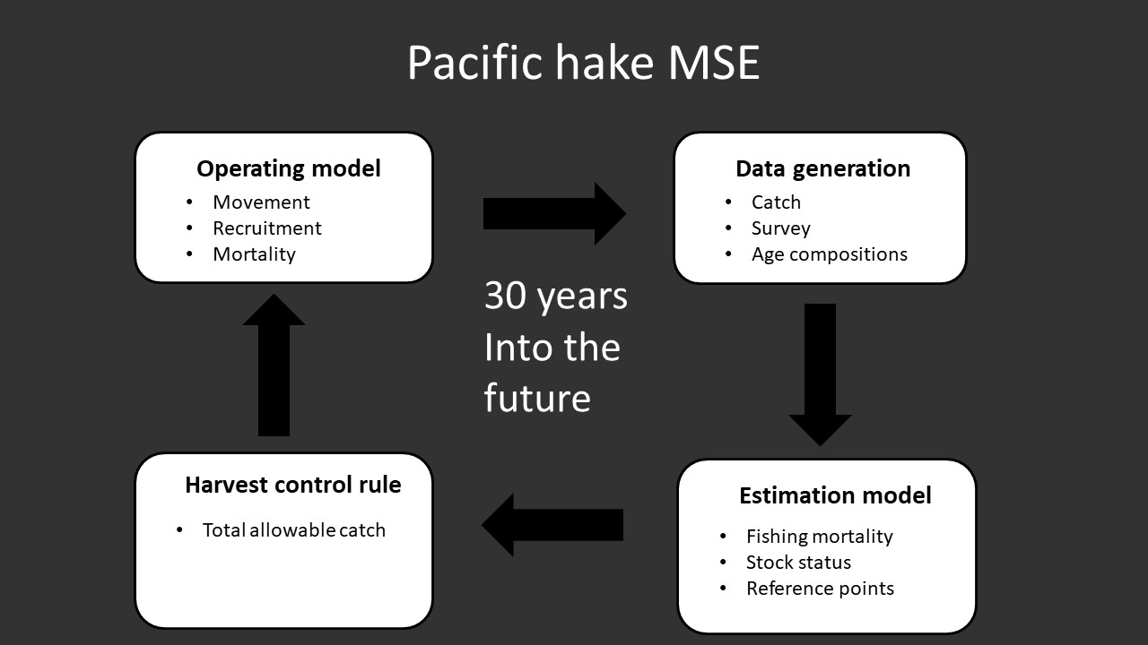

Figure 1 Conceptual description of the four components of the Pacific hake management strategy evaluation (MSE) closed-loop simulation model.

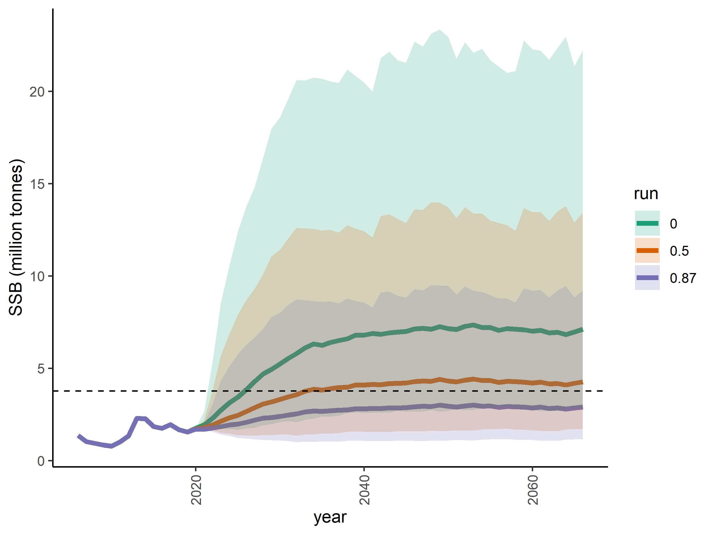

Figure 2 Equilibrium biomass in the future without fishing. The three different colors represent different bias adjustments, and the shaded area is the 5th and 95th percentiles (1000 iterations). The dashed line represents unfished spawning biomass .

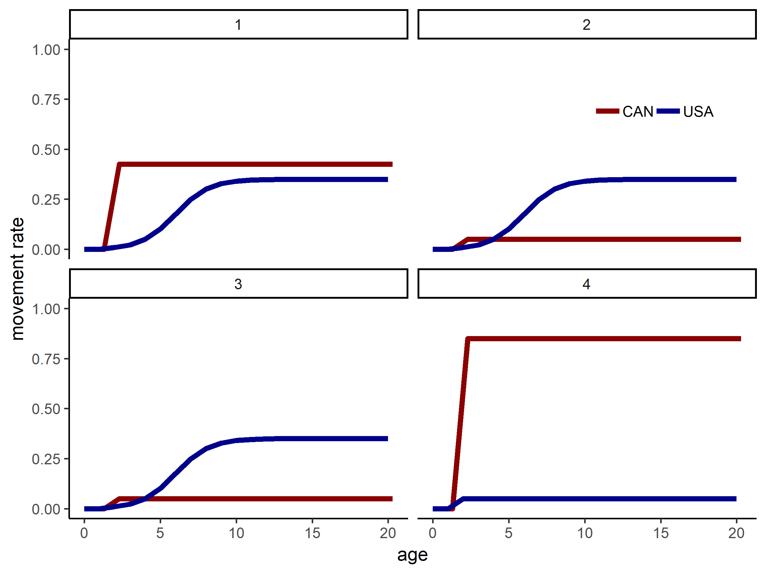

Figure 3 Assumed movement rates as a function of age in the four seasons in the operating model. The number above each plot represents the season.

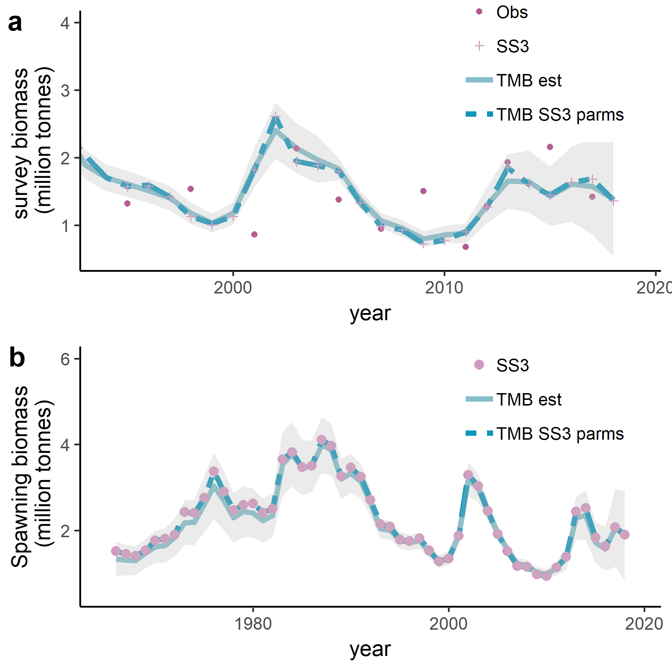

Figure 4 Comparison of the TMB estimation model and the hake stock assessment model shown by a) the estimated survey abundance, and b) the estimated spawning stock biomass . ‘Obs’ is observed survey data, ‘SS3’ is the hake stock assessment model, ‘TMB est’ is the TMB estimation model, and ‘TMB SS3 parms’ refers to the TMB EM initialized with the parameters from the hake SS3 stock assessment model . The gray shading indicates the confidence intervals from the TMB estimation.

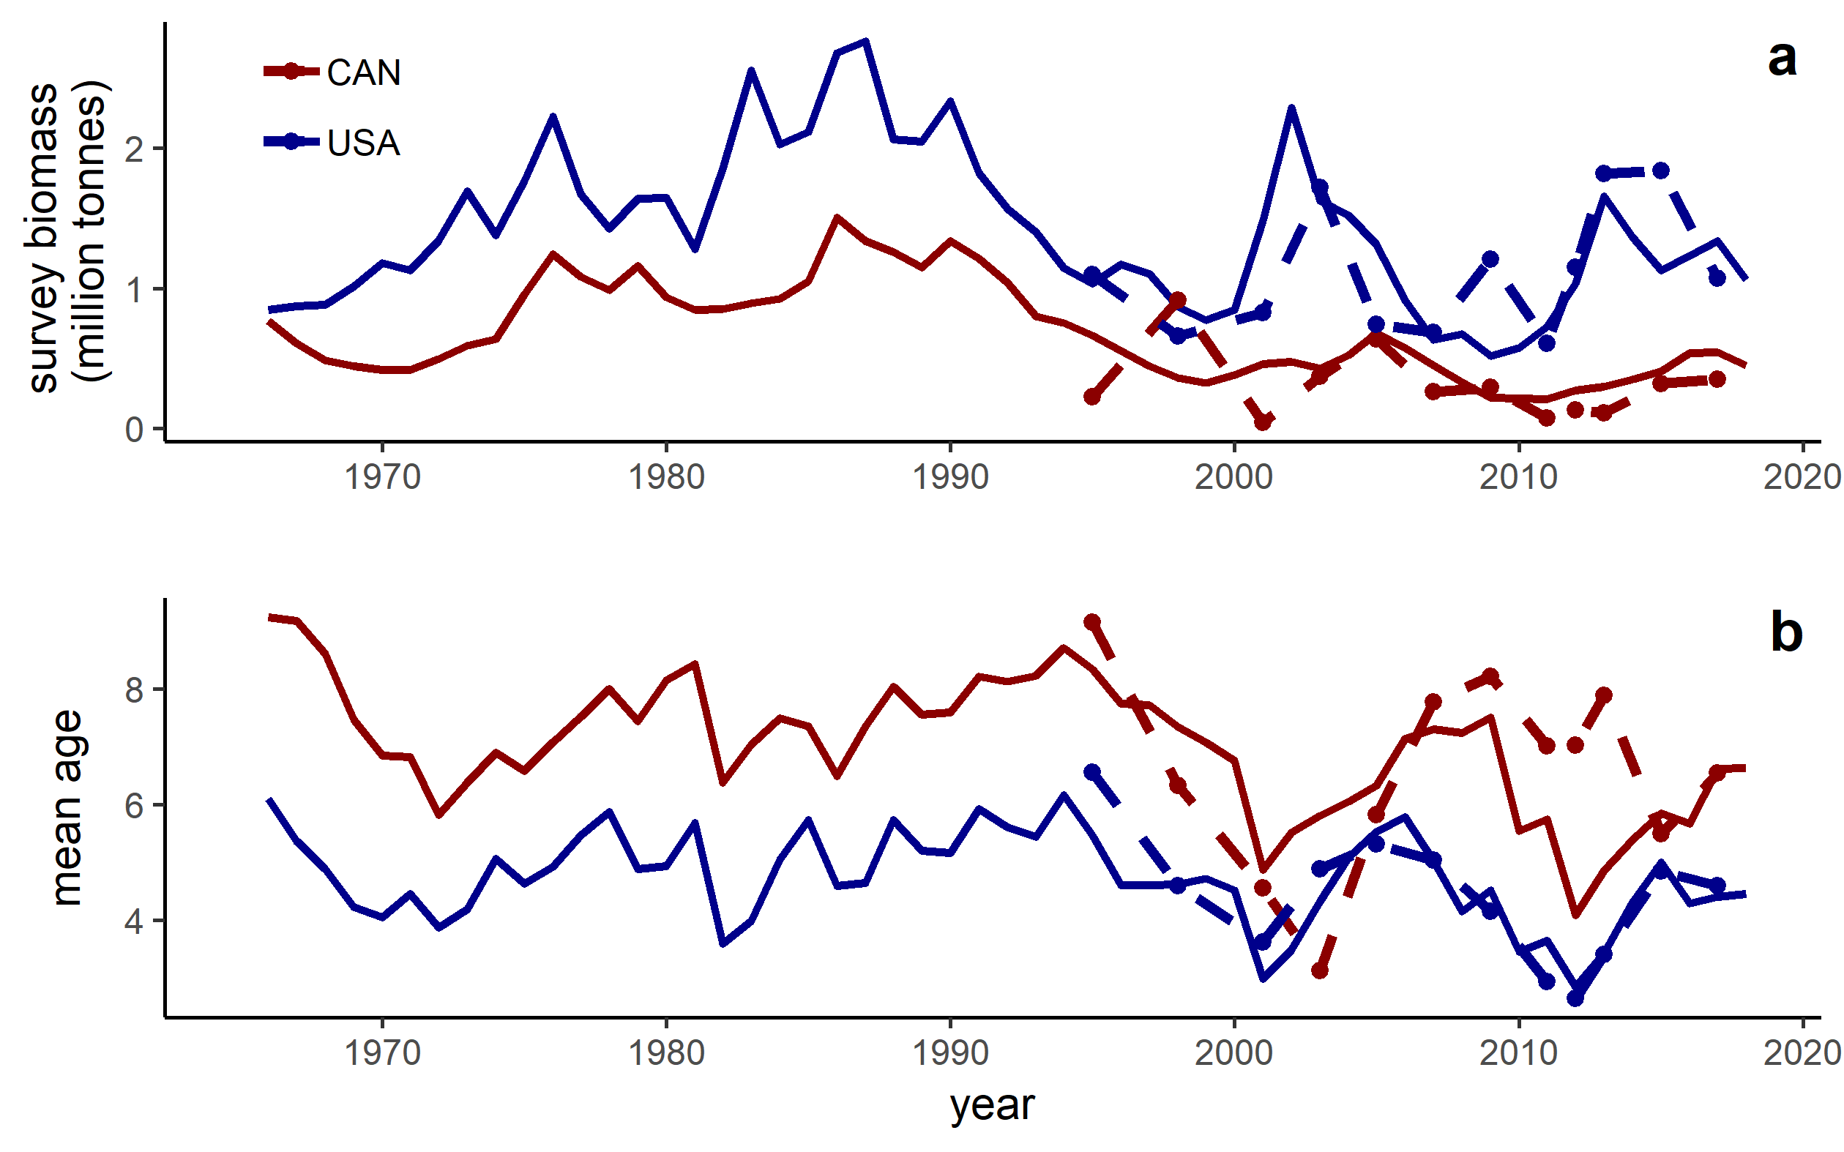

Figure 5 Conditioning of the operating model, with the country specific survey biomass (a) and the average age in the survey (b). Dashed-dotted line represents the data from the survey, and the solid lines represents the output from the operating model. Blue represents the fish present in the US and red represents the fish present in Canada.

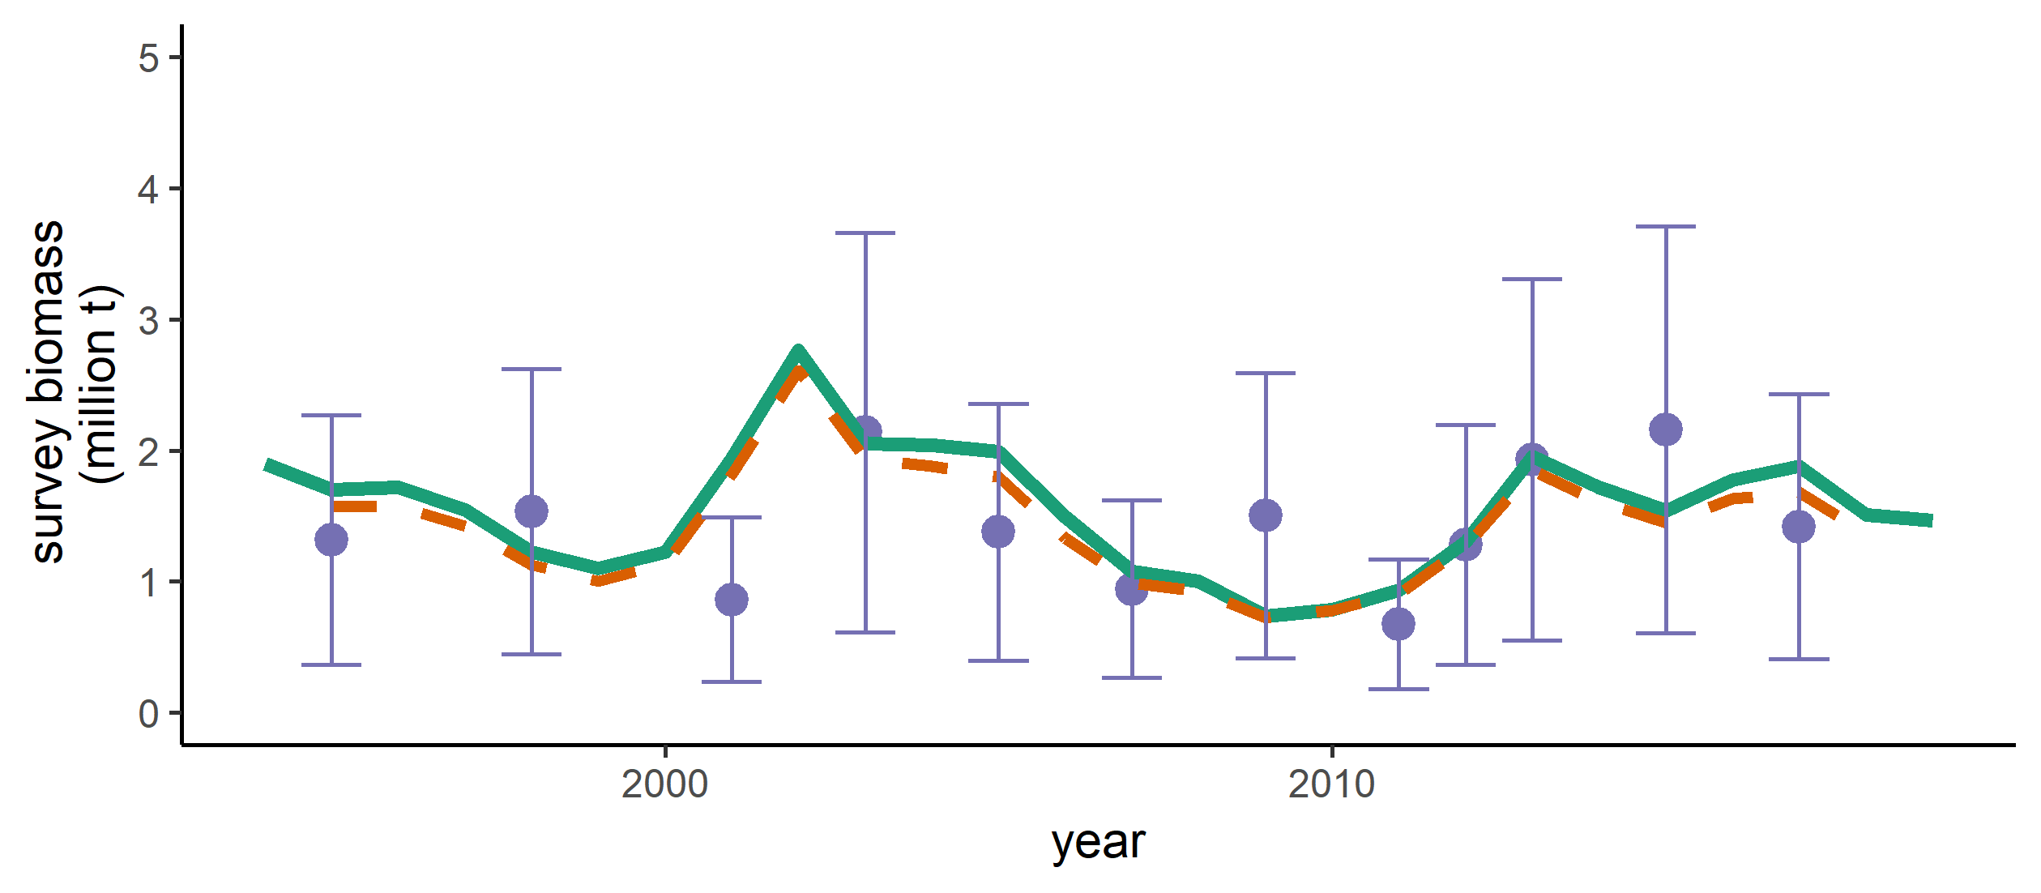

Figure 6 Total survey biomass in the operating model (green), assessment model (dashed orange), and observed data with associated uncertainty (purple dots).

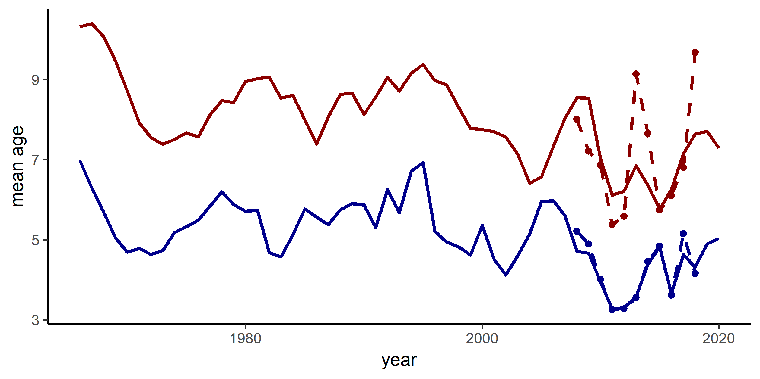

Figure 7 Average age in the catches in the operating model (red: Canada, blue: USA). Solid lines denote the median. The dashed lines with dots denote the observed average ages from the catches.

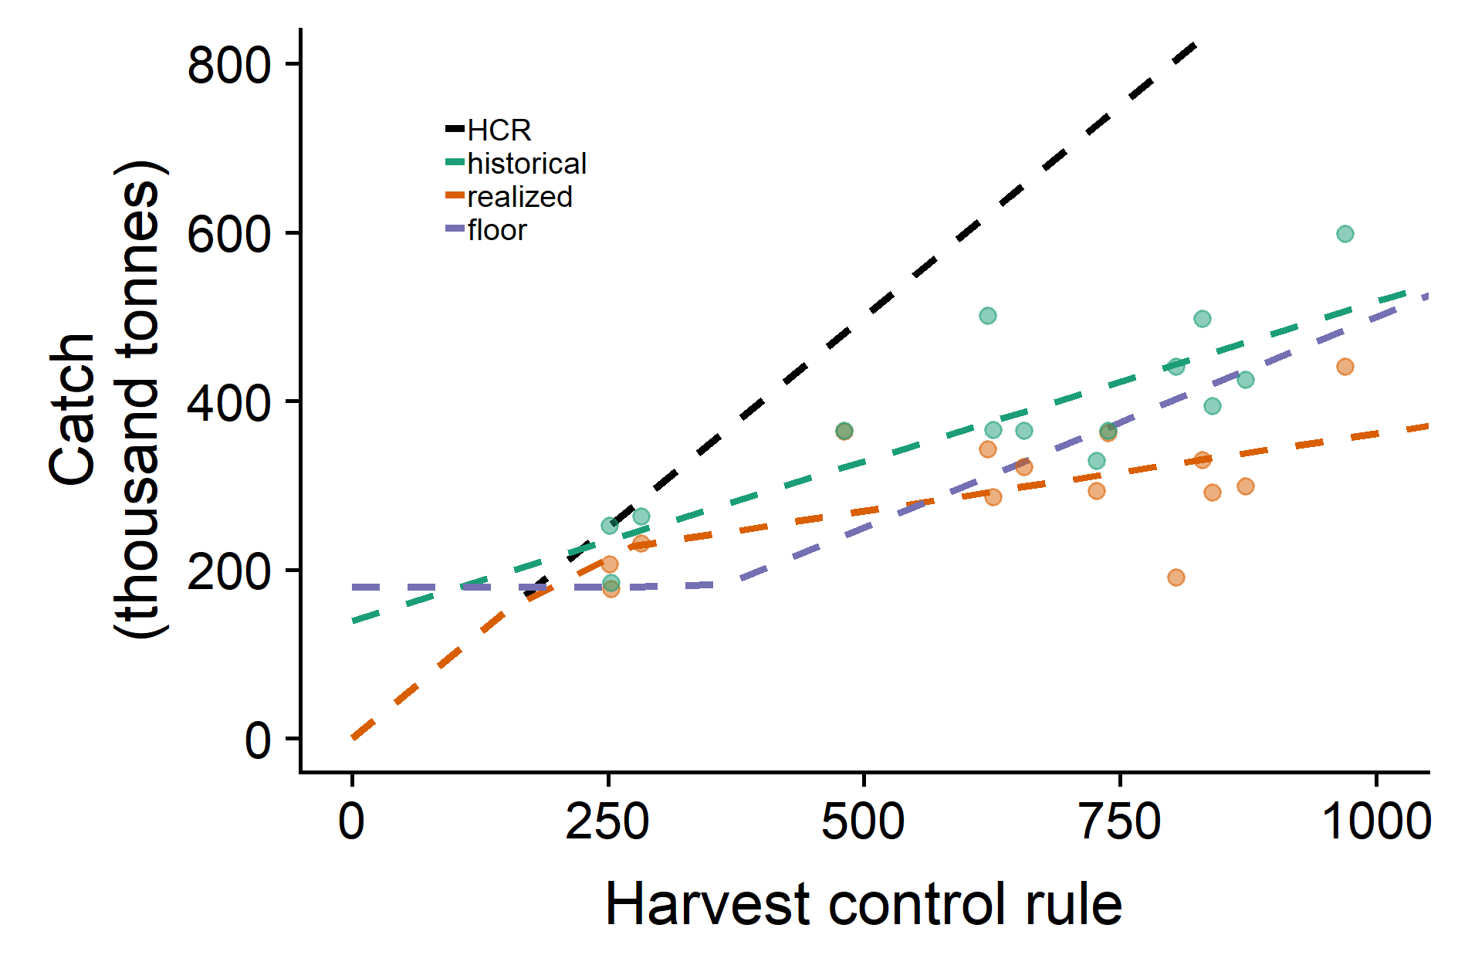

Figure 8 The different implementation scenarios, where lines represent the total allowable catch in the four different scenarios (the x-axis being the Treaty harvest control rule TAC calculated in equation 18). The dots represent the historical catch given the Treaty har

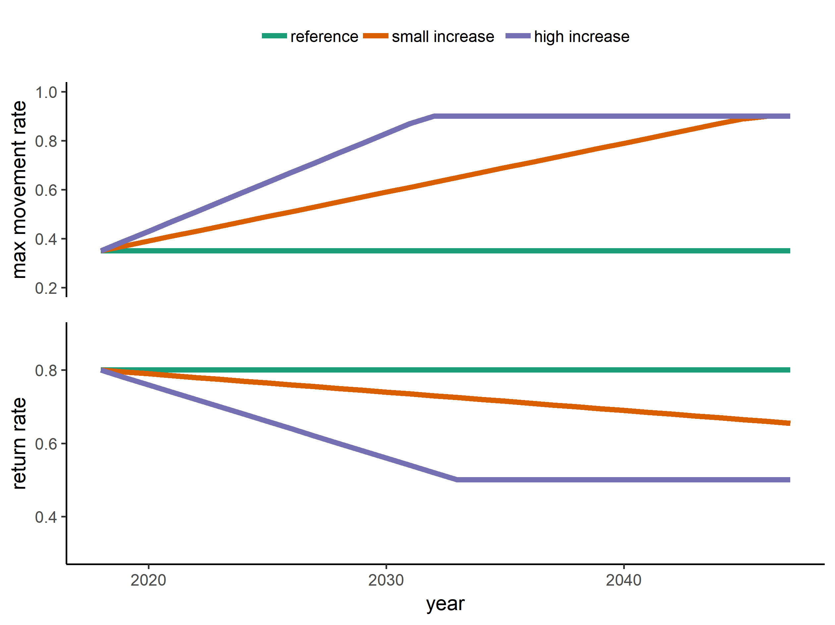

Figure 9 The changes in movement rate in the three different climate scenarios. Max movement rate is κ whereas the return rate is κ_return (see also figure 2).

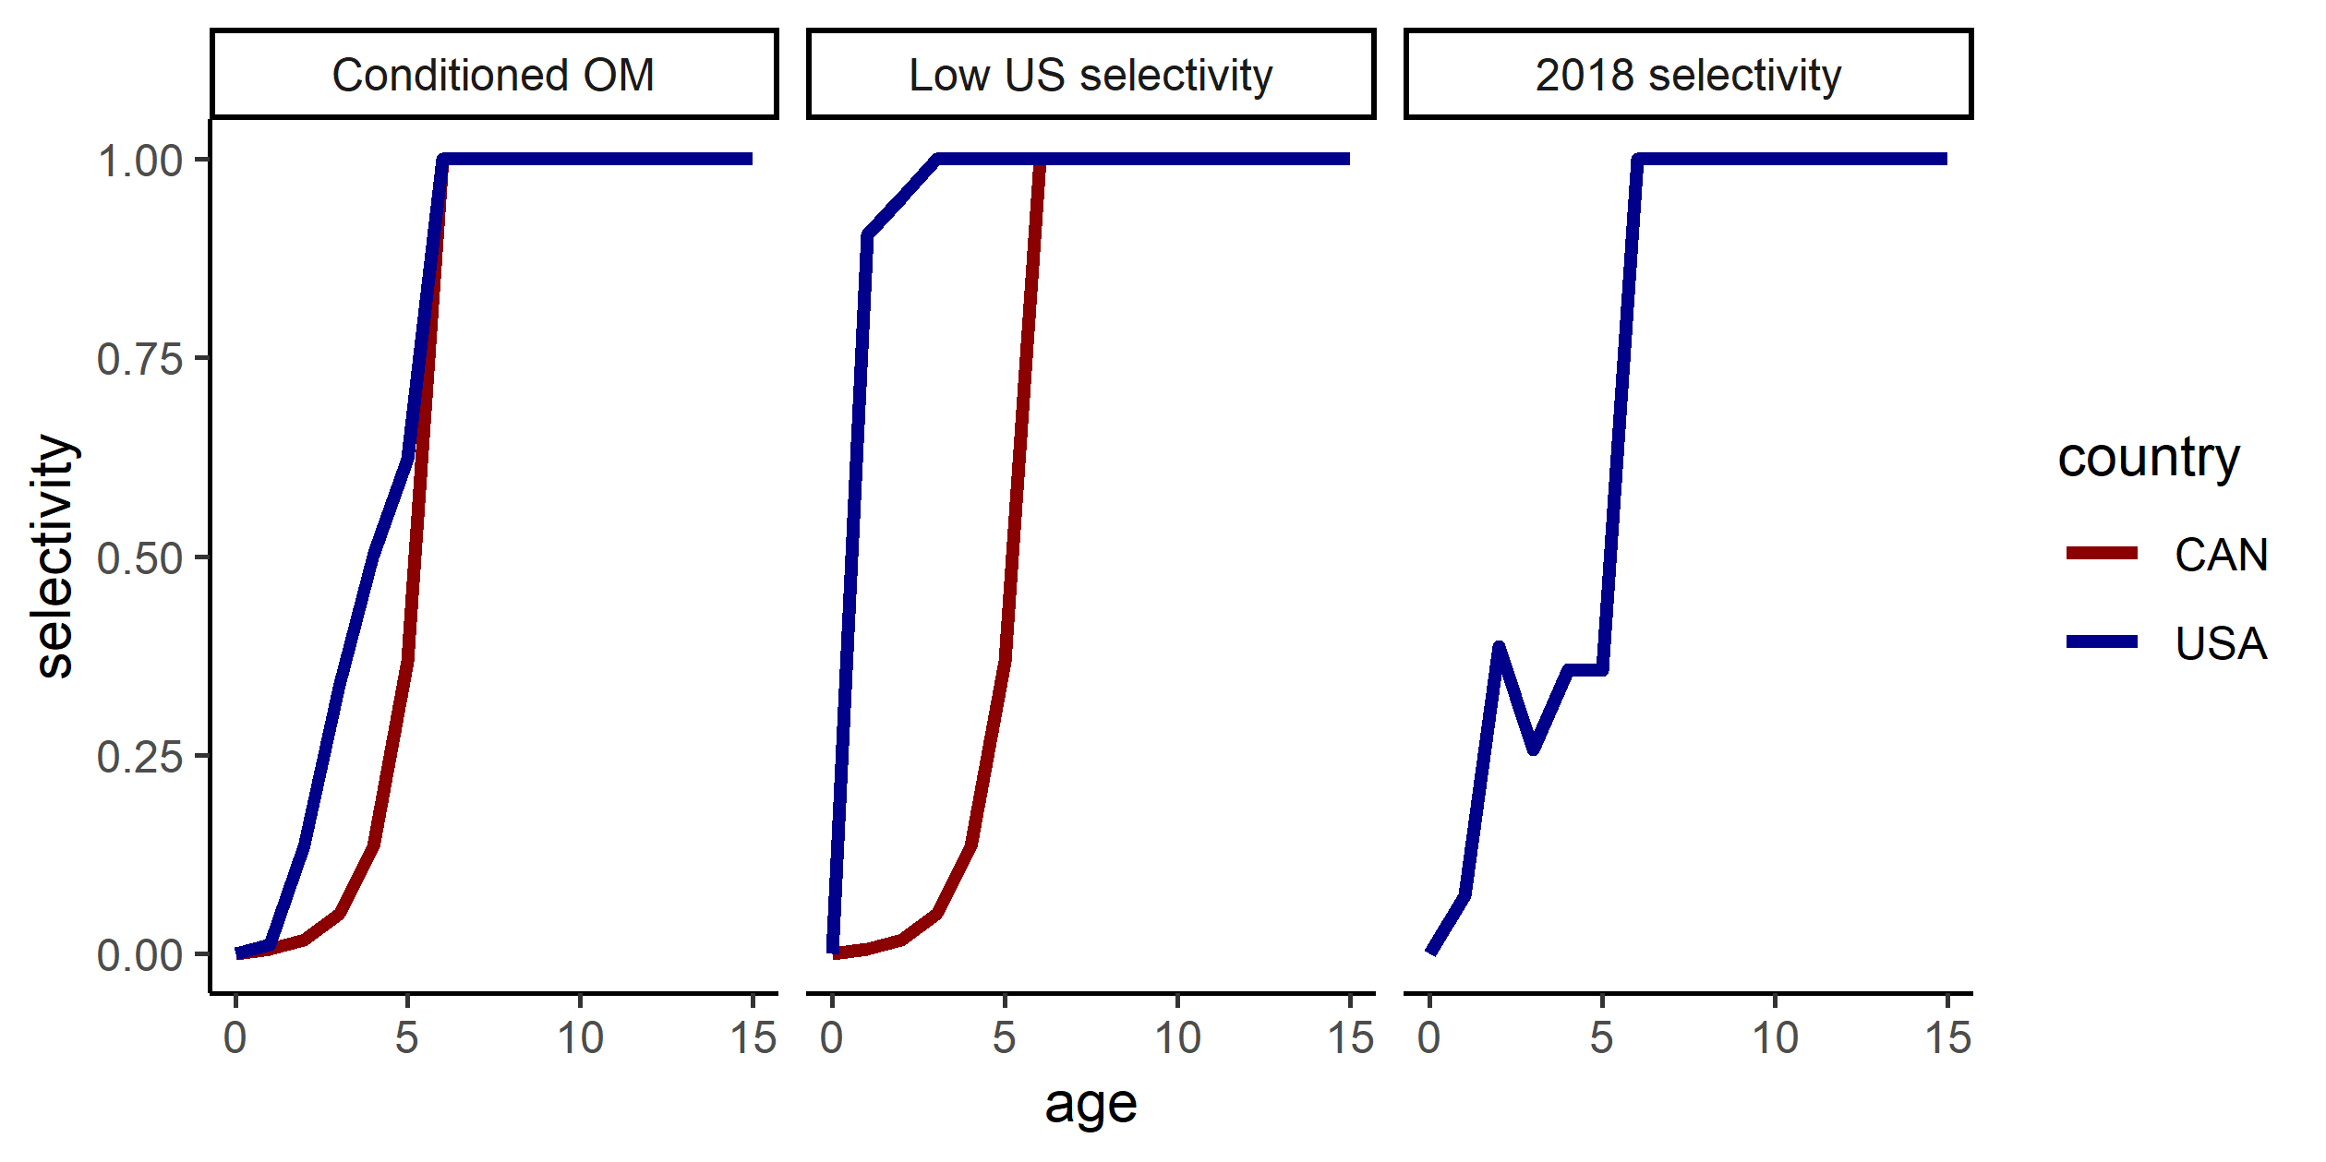

Figure 10 The selectivity in the three different selectivity scenarios. The 2018 selectivity scenario has the same selectivity for both countries.

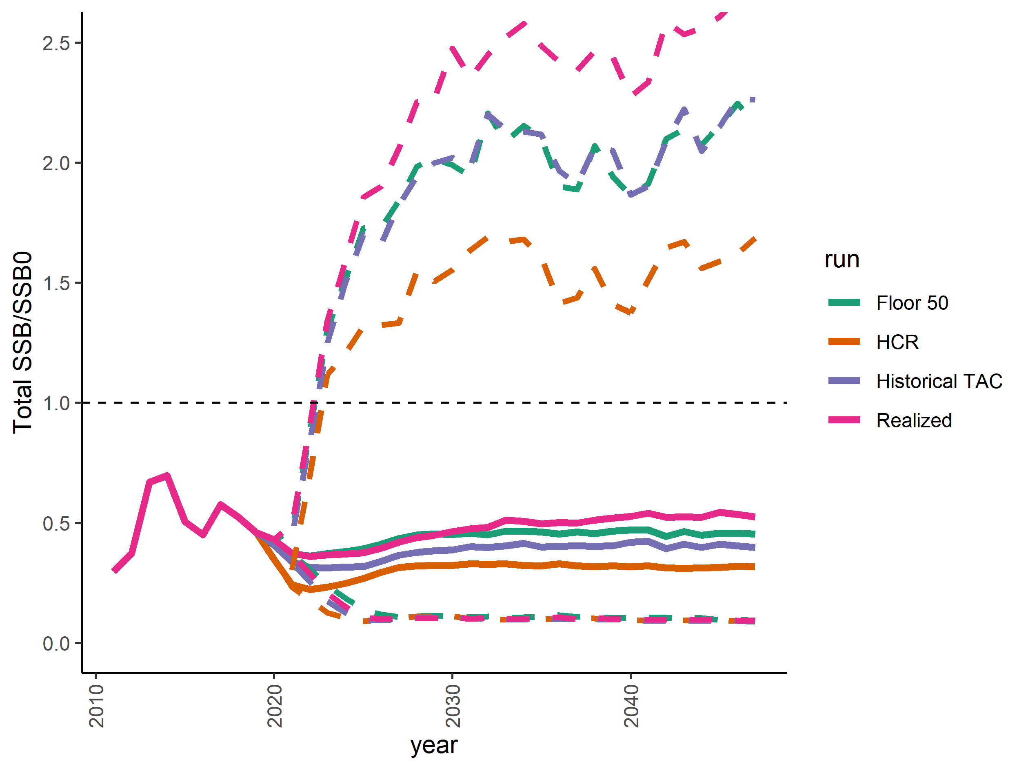

Figure 11 Median total future spawning stock biomass in the alternative implementation scenarios. Colors indicate the four different scenarios, and dashed lines indicate the 95th and 5th quantiles.

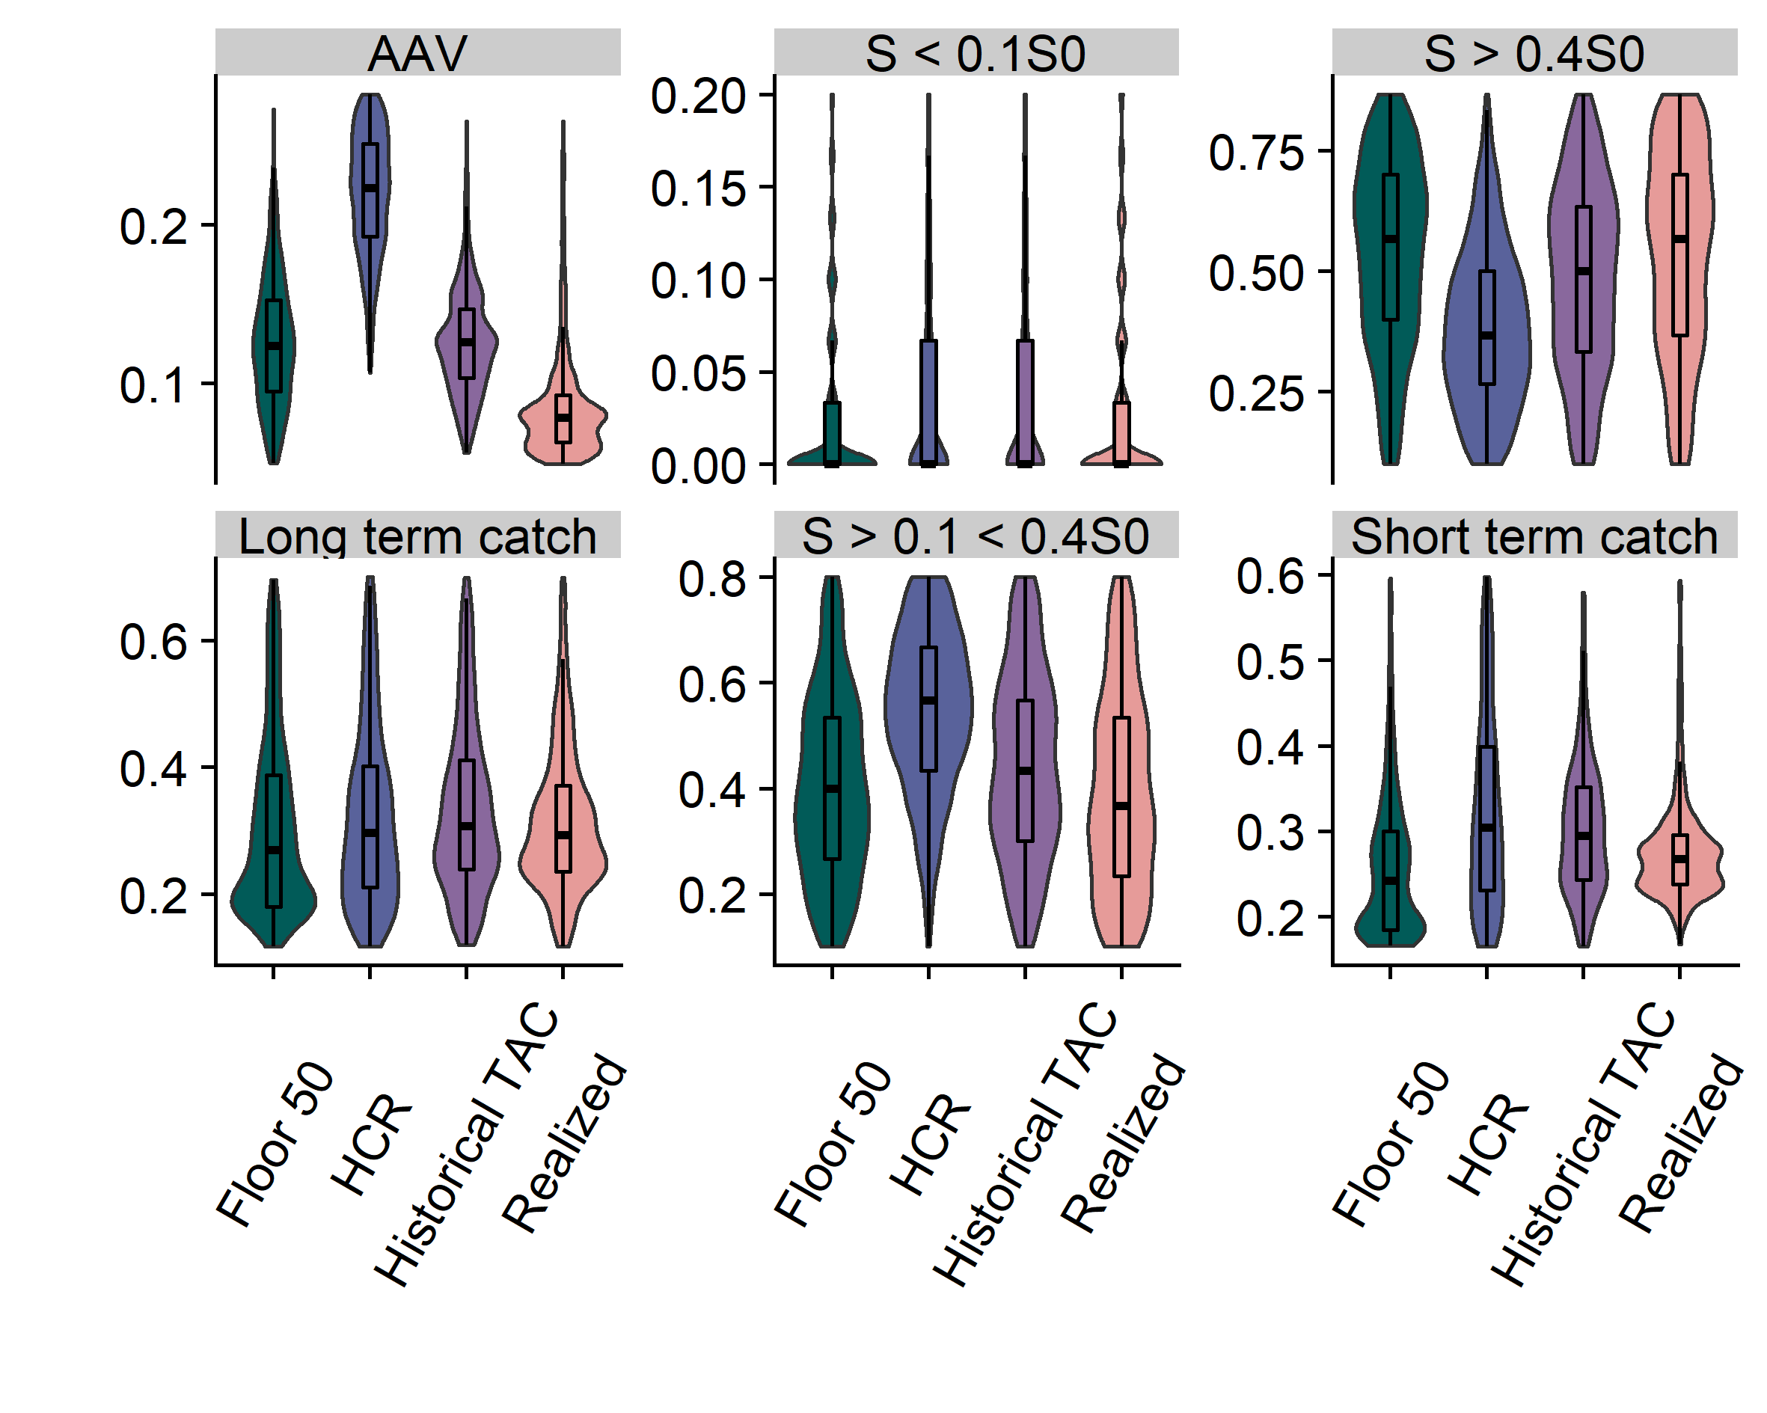

Figure 12 Violin plots of performance metrics in the ‘alternative implementation’ scenarios with the four different colors representing four harvest control rules in equation 19-21, as well as the rule that sets a floor on the allowable catch (see main text). The 95th and 5th percentiles have been removed from the plots for visual purposes.

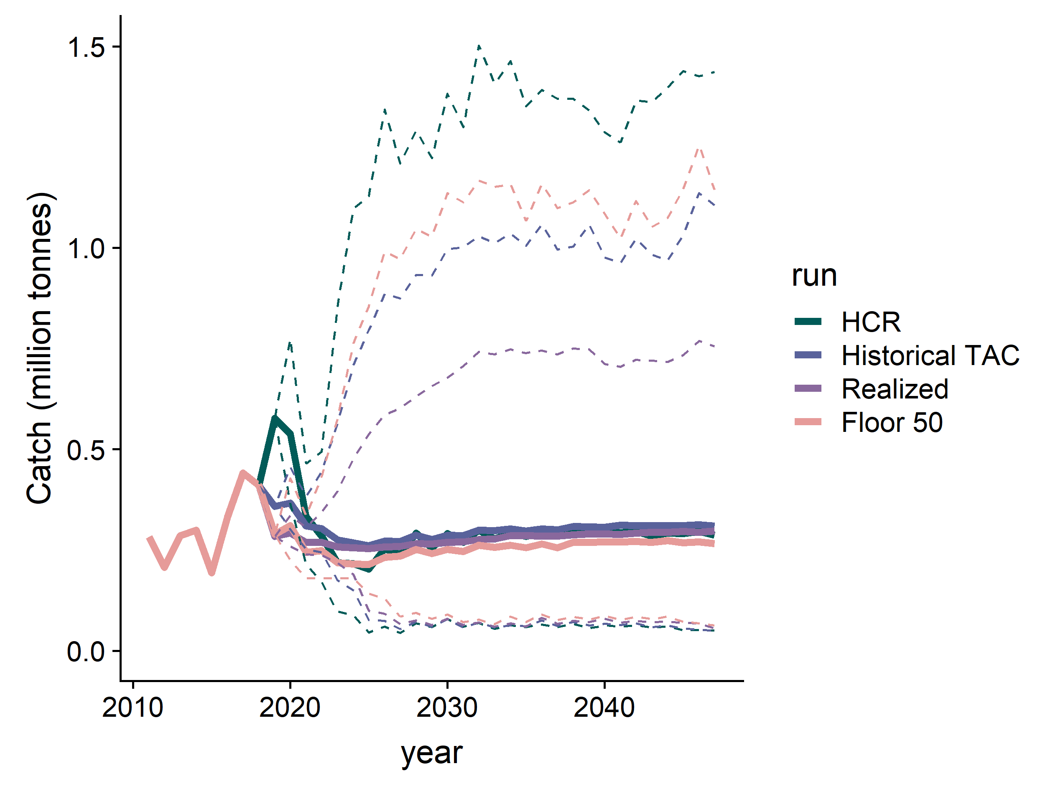

Figure 13 Future projections of coastwide catch in the four ‘alternative implementation’ scenarios. Solid lines represent the median, and dashed lines represent the 5th and 95th percentiles.

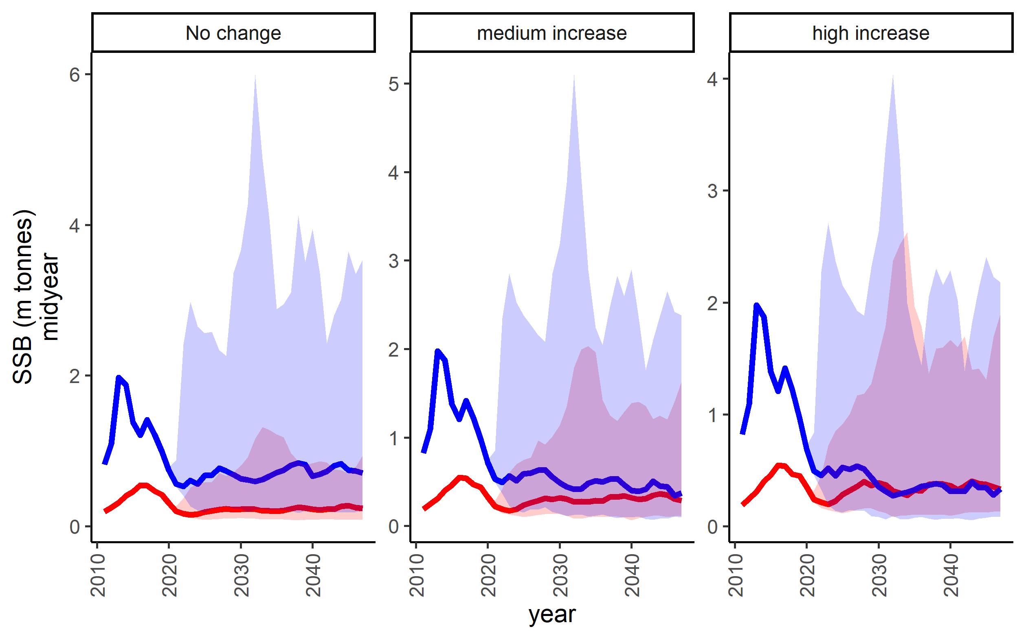

Figure 14 *Spawning stock biomass in the middle of the year in the climate change scenarios for the US (blue) and Canda (red). Shading indicates 5th and 95th percentiles. The ‘high change’ scenario causes a larger fraction of the spawning biomass to stay in Canada over time.*

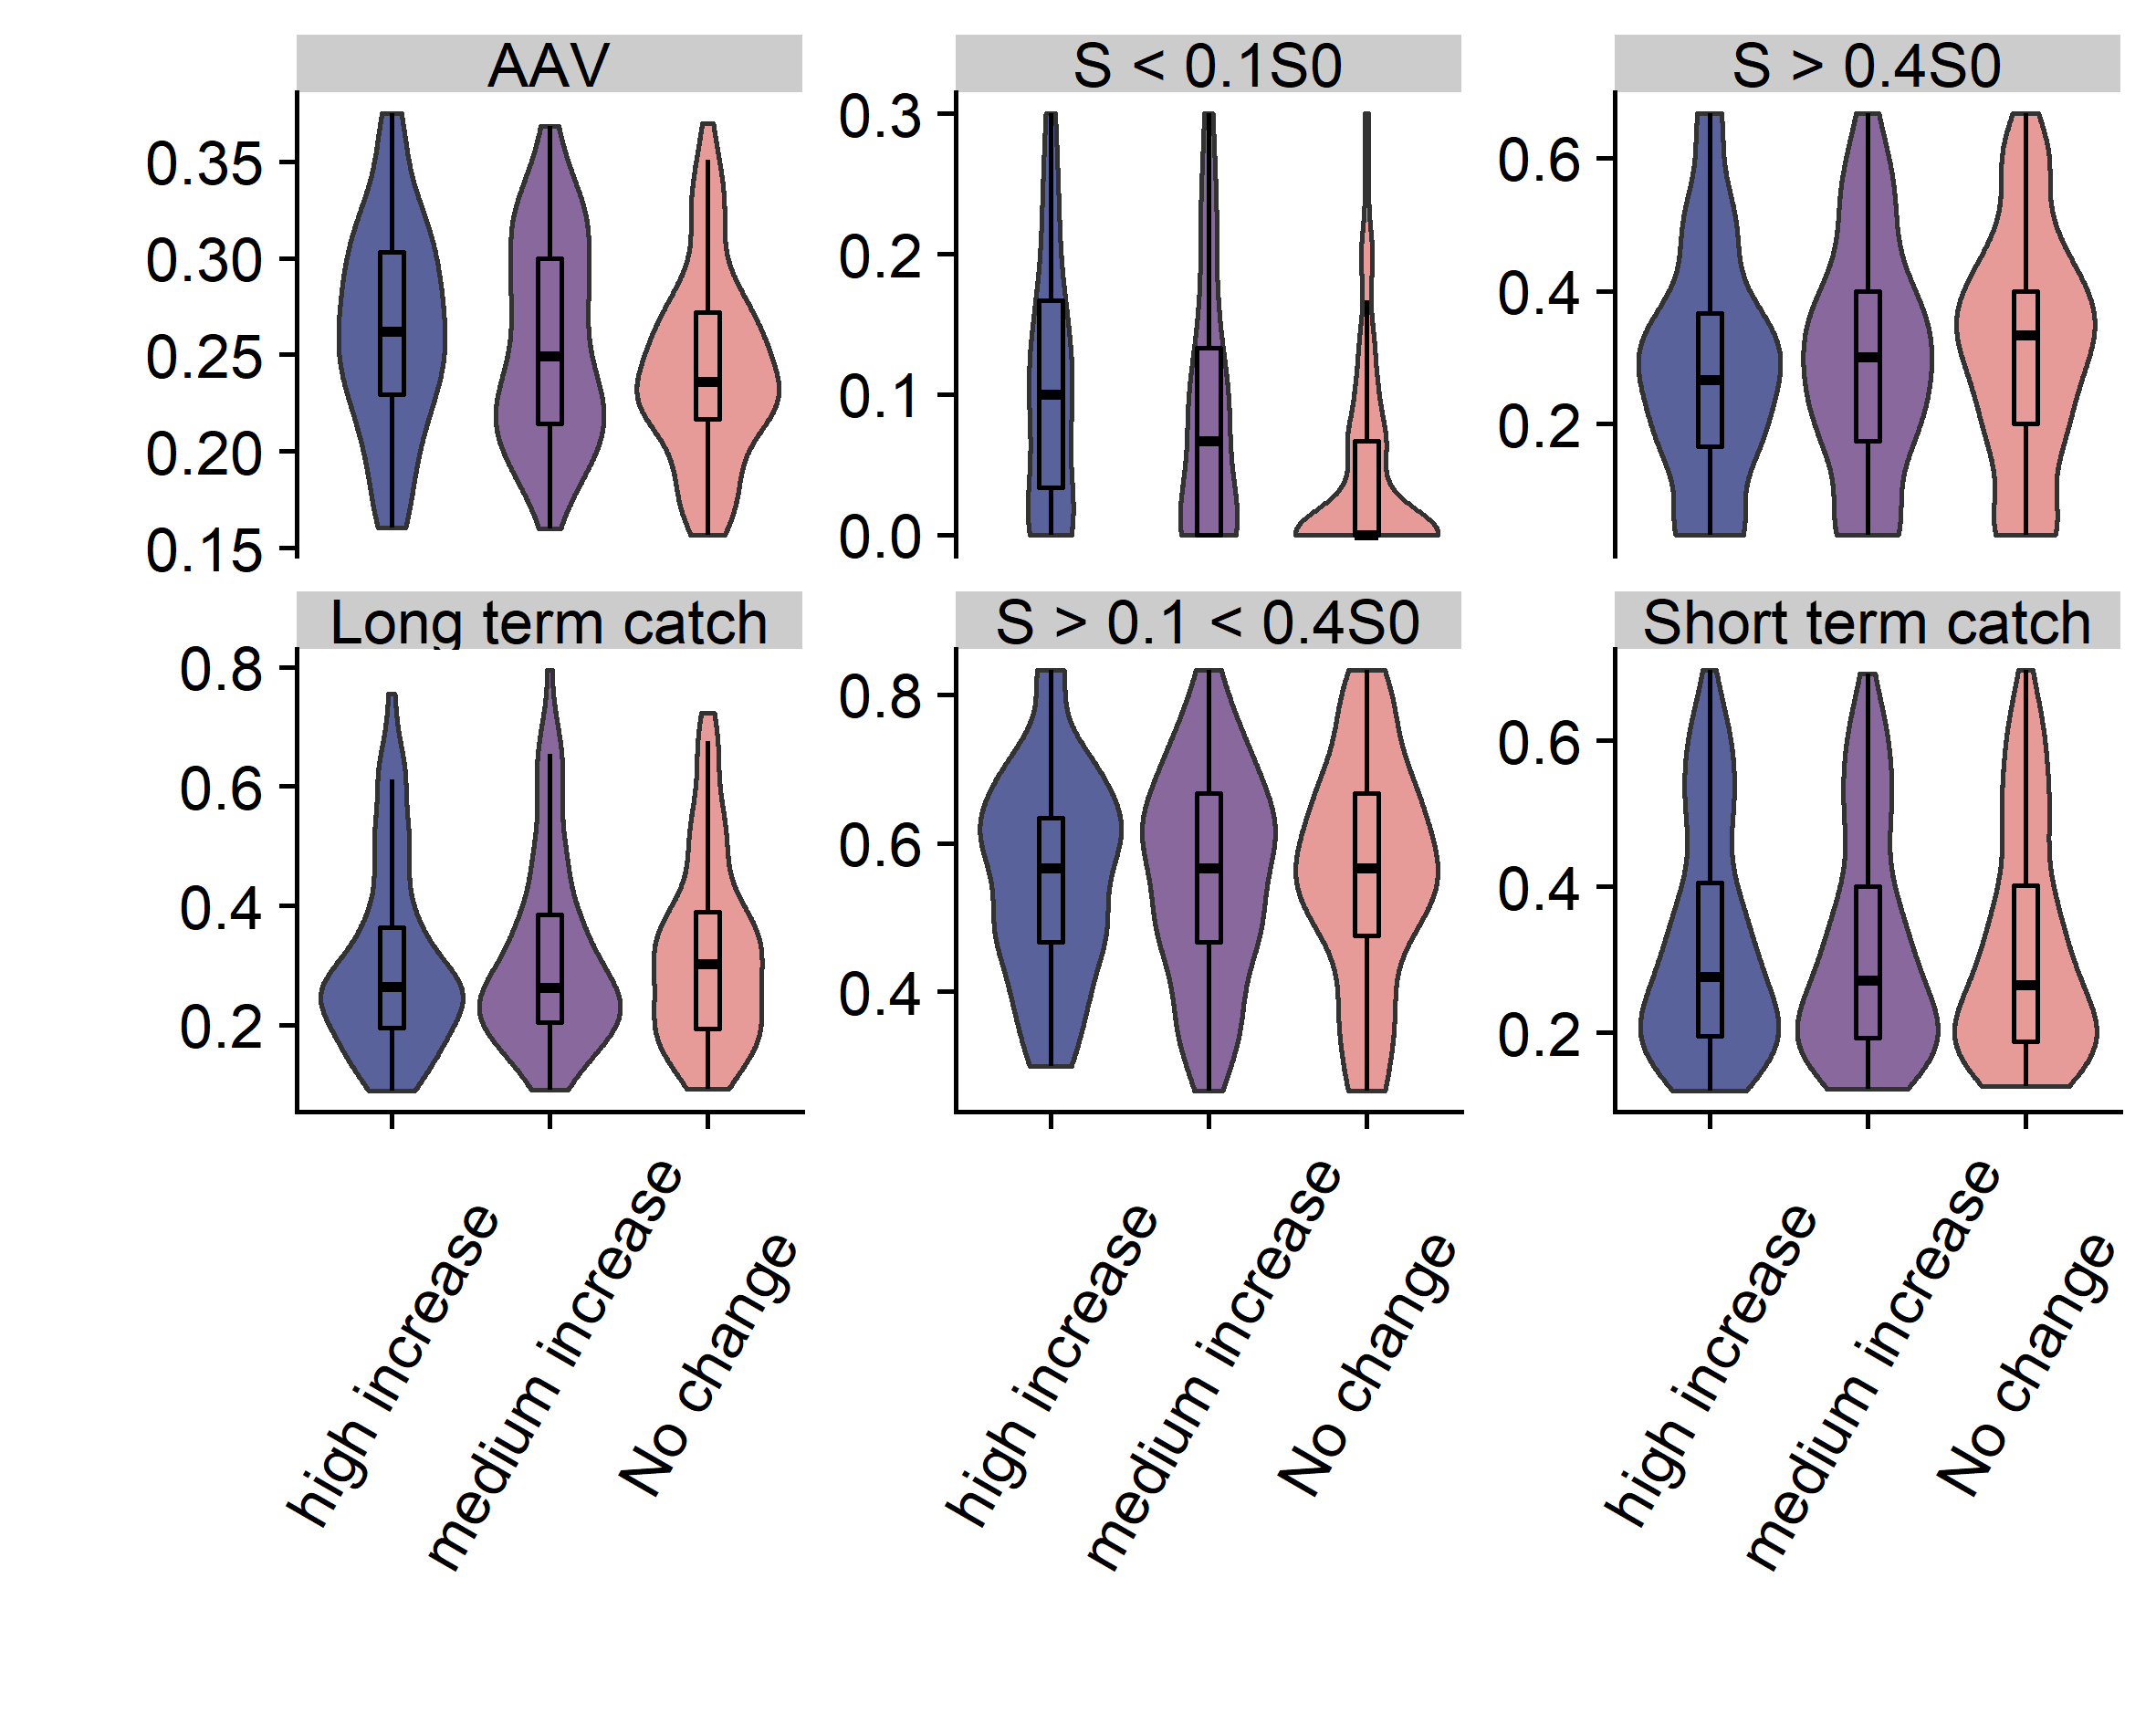

Figure 15 Performance metrics for alternative ‘climate change’ scenarios with the 3 different colors representing the climate change movement scenarios in figure XX. 1) No change, 2) medium increase, 3) high increase in movement

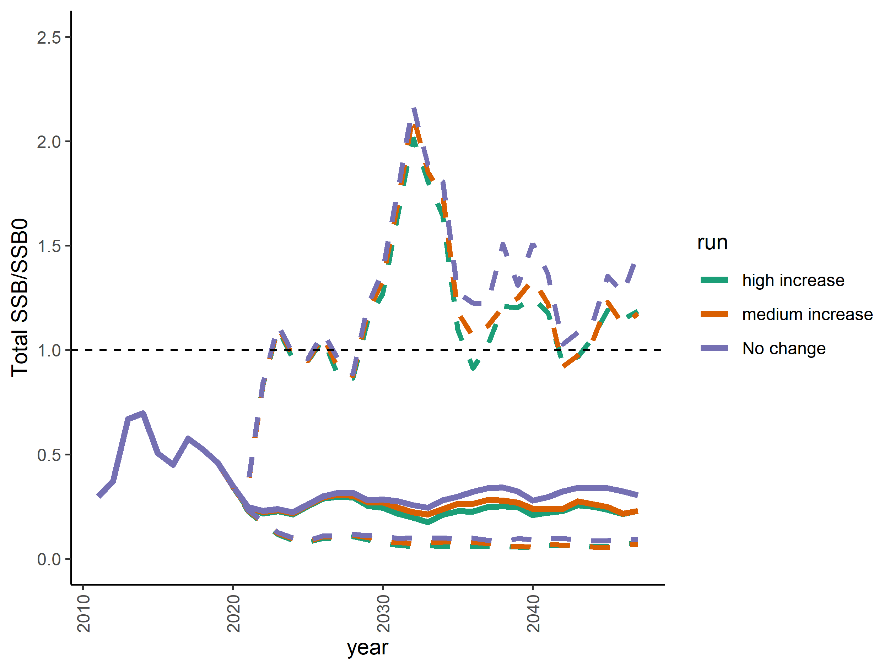

Figure 16 Total future spawning stock biomass in the climate change scenarios. Colors indicate the three scenarios, solid lines represent the median and dashed lines indicate the 95th and 5th percentiles of 1000 simulations.

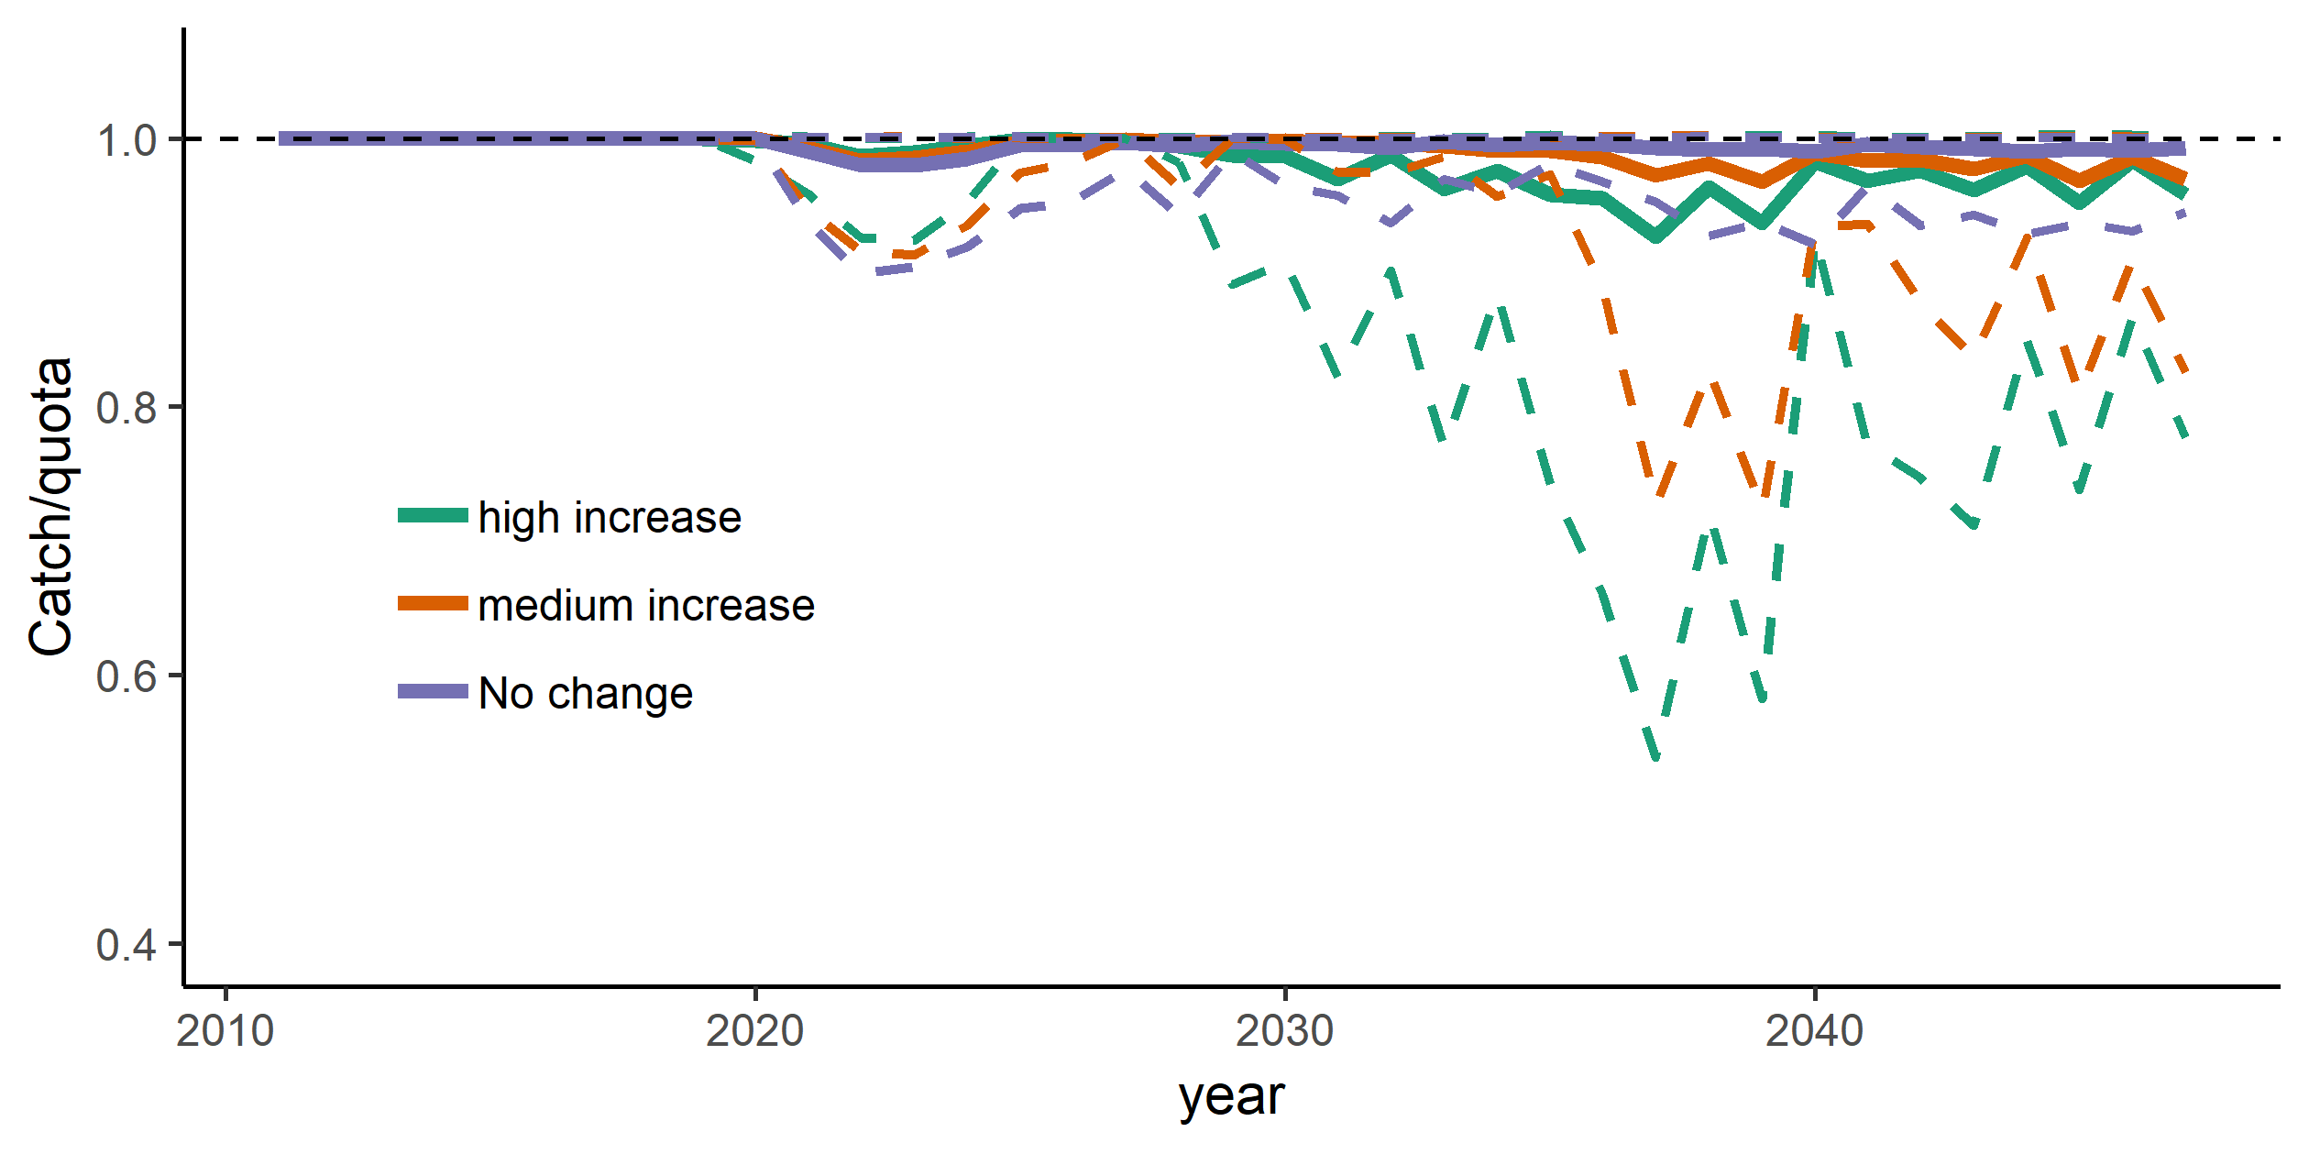

Figure 17 The realized catch divided by the given quota in the climate change scenario (i.e., a value under 1 indicates that the quota was not met due to spatial restraints). Dashed lines indicate 95th and 5th confidence intervals.

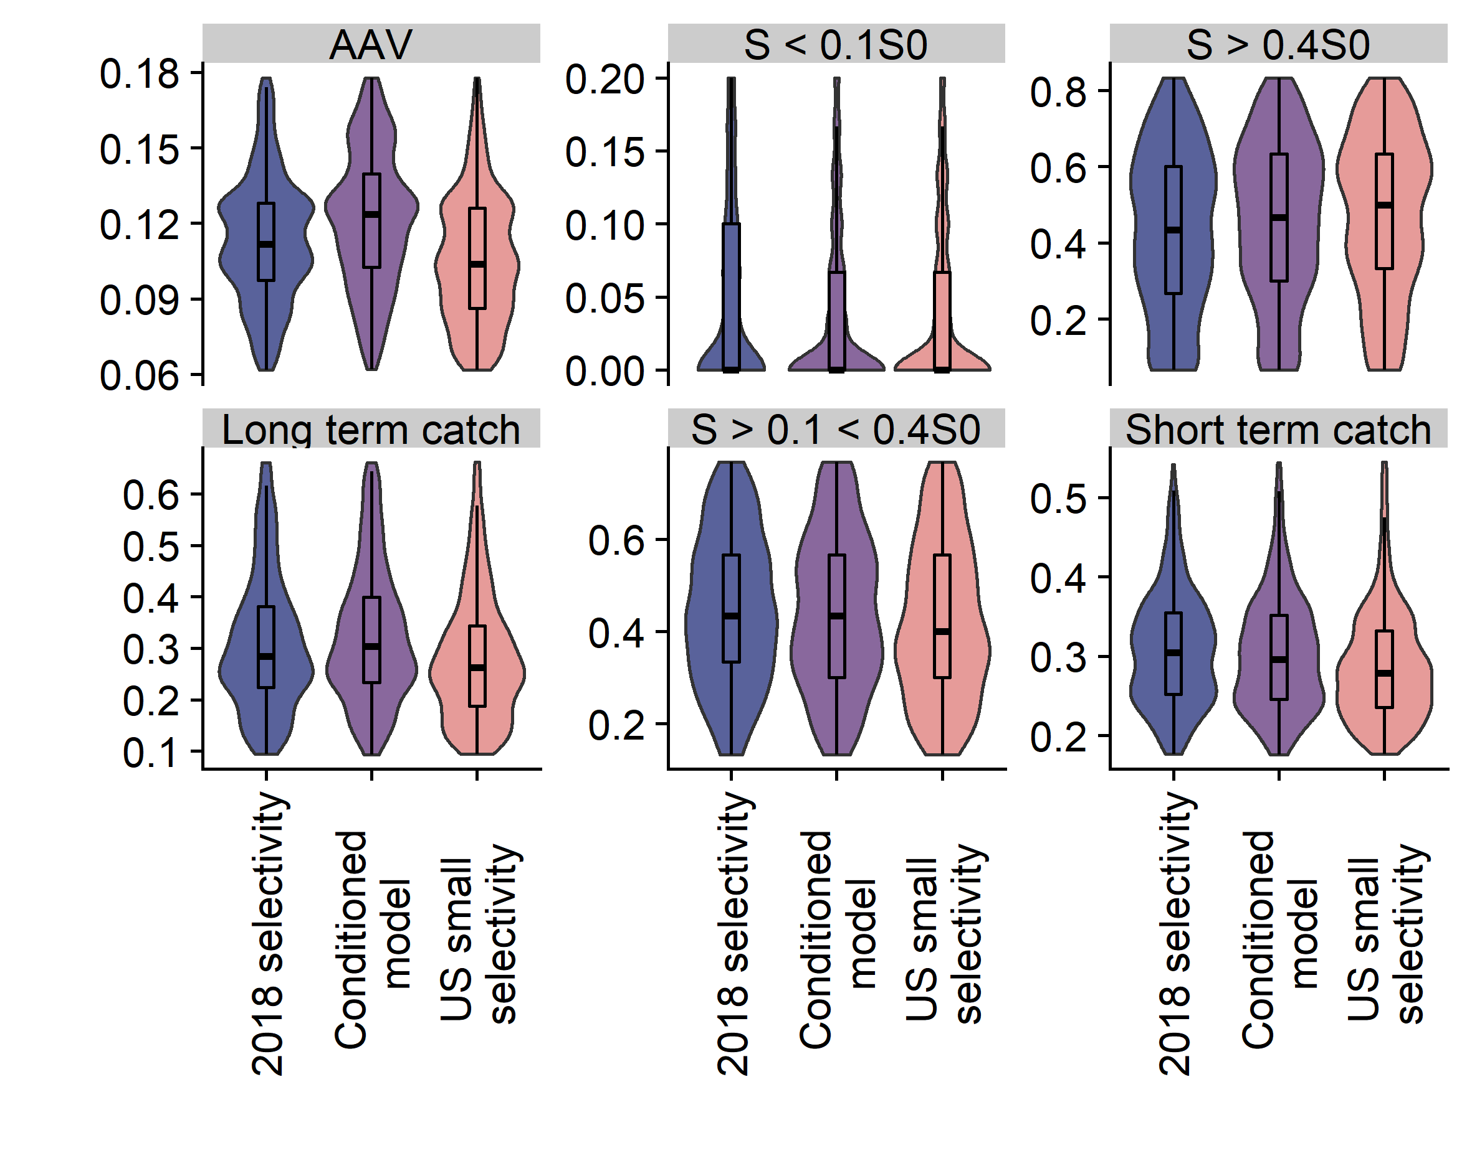

Figure 18 Performance metrics for alternative ‘selectivity’ scenarios. The different selectivity patterns are shown in figure 9. For definitions on performance metrics and how they relate to management objectives see the main text.

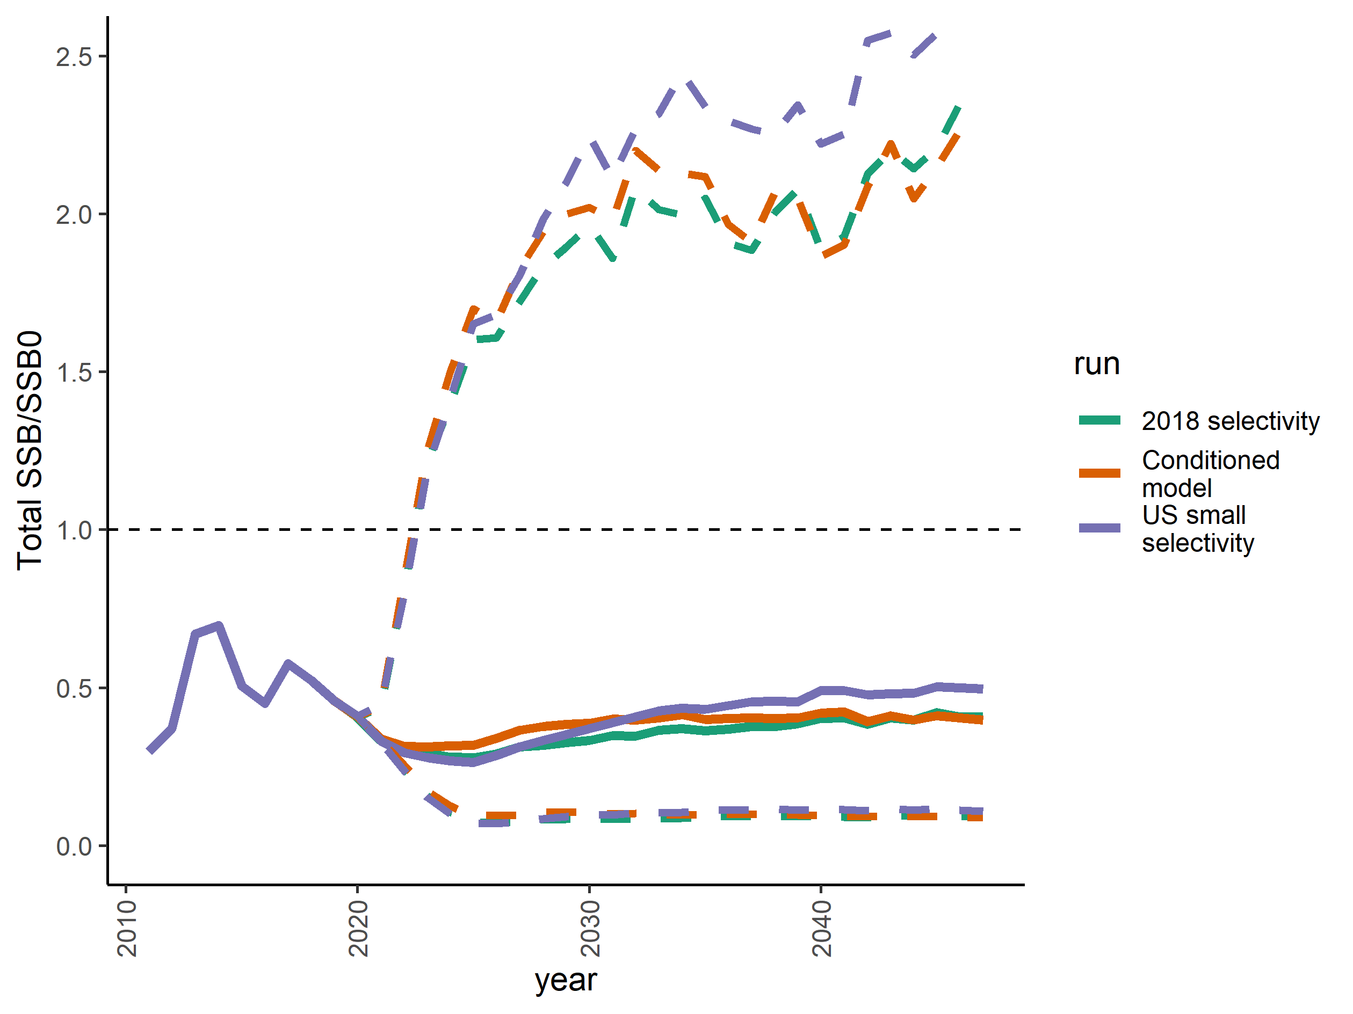

Figure 19 Coastwide spawning biomass in the three different selectivity scenarios. Solid lines indicate the median and dashed lines indicate the 5th and 95th percentiles of 1000 simulations.

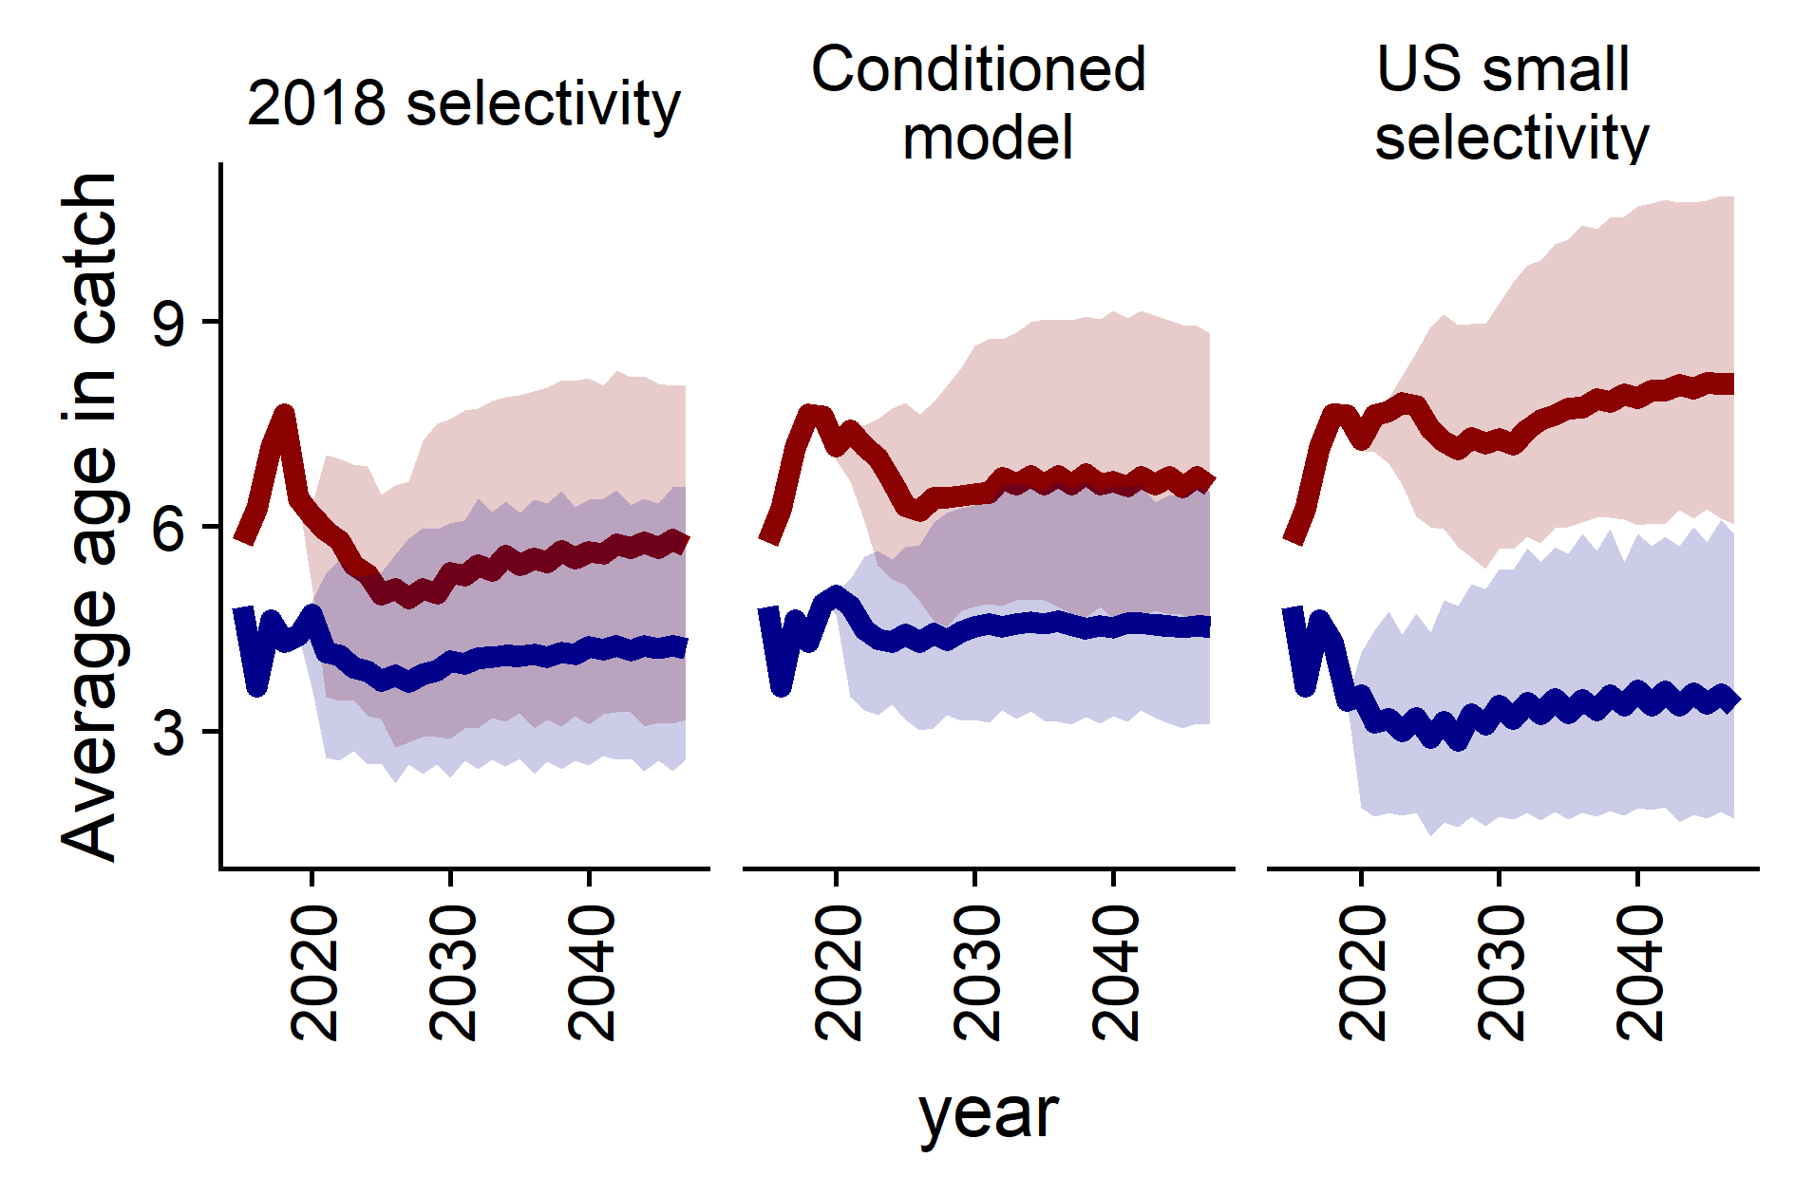

Figure 20 Average catch at age in the ‘selectivity’ scenarios. Blue line represents the US and red line represents Canada

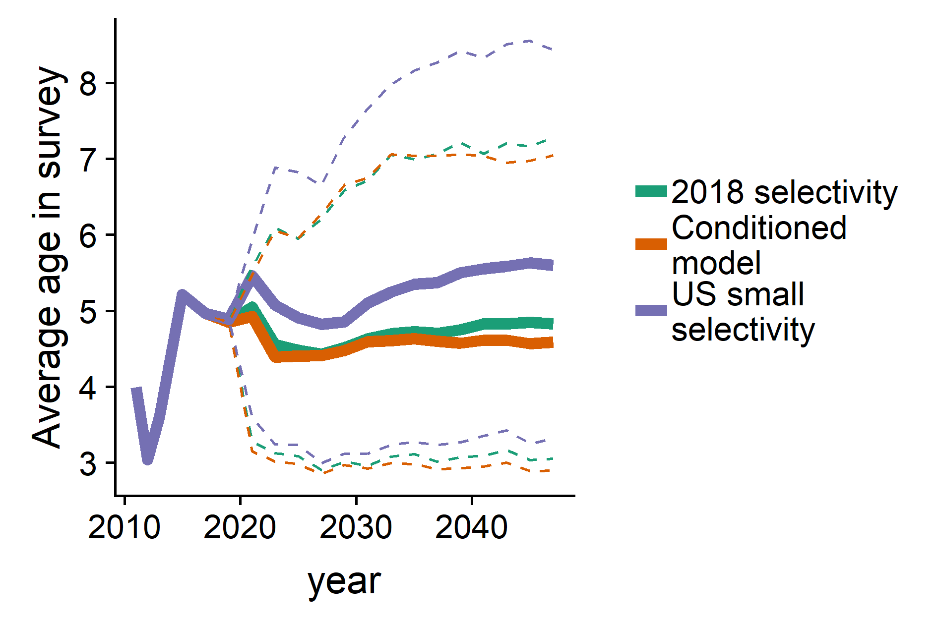

Figure 21 Median average age in the survey (full lines) in the three different selectivity scenarios. Dashed lines are the 95th and 5th percentiles.

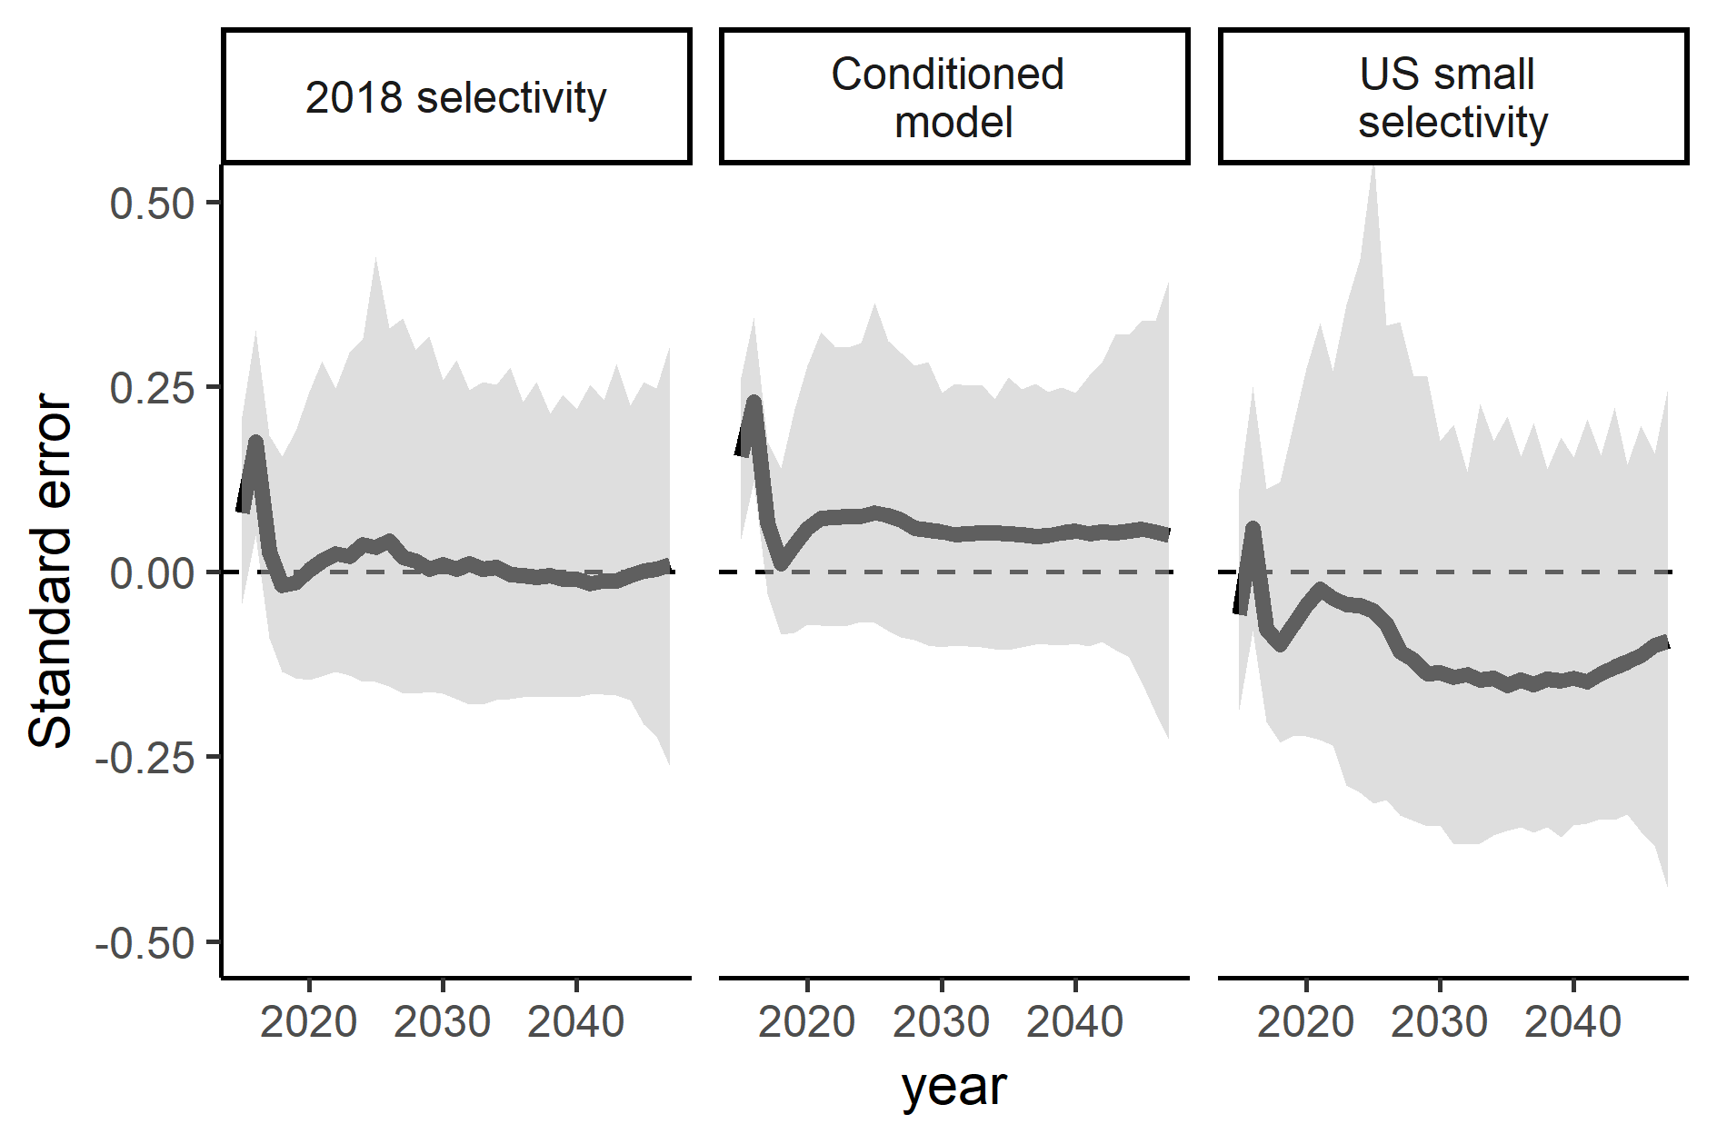

Figure 22 Relative standard error of estimated to real spawning stock biomass in the three ‘selectivity’ scenarios. Black lines denote the median and shading denotes the 95th and 5th percentiles.

# Glossary of Terms for Pacific Hake Management Strategy Evaluation

**40:10 adjustment**: a reduction in the overall total allowable catch that is triggered when the female spawning biomass falls below 40% of its unfished equilibrium level. This adjustment reduces the total allowable catch on a straight-line basis from the 40% level such that the total allowable catch would equal zero when the biomass is at 10% of its unfished equilibrium level. This is one component of the default harvest policy (see below).

**Closed-loop simulation model**: A subset of an MSE that iteratively simulates a population using an operating model, generates data from that population and passes it to an estimation model, uses the estimation model and a management strategy to provide management advice, which then feeds back into the operating model to simulate an additional fixed set of time before repeating this process.

**Conditioning**: The process of fitting an Operating Model (OM) of the fish population dynamics to the available data. The aim of conditioning is to select those OMs consistent with the data and reject OMs that do not fit these data satisfactorily and, as such, are implausible.

**Default harvest policy (rate)**: The application of FSPR=40% (see below) with the 40:10 adjustment (see above). Having considered any advice provided by the JTC, SRG or AP, the JMC may recommend a different harvest rate if the scientific evidence demonstrates that a different rate is necessary to sustain the offshore Pacific Hake/whiting resource.

**Estimation Model (EM)**: a sub-model of a closed-loop MSE simulation model that performs a stock assessment using data from the observation model

**Exploitation fraction**: A metric of fishing intensity that represents the total annual catch divided by the estimated population biomass over a range of ages assumed to be vulnerable to the fishery (set to ages 2+ in the current hake assessment).

**Harvest Control Rule (HCR)**: A rule that describes how the harvest is to be managed (e.g., catch- or effort-related limits) based on the state of a specified indicator(s) of stock status. Also known as a decision rule. For Pacific hake, see default harvest policy (above).

**Harvest Strategy:** A pre-agreed framework for recommending or making fisheries management decisions, such as setting catch limits, that is designed to achieve specific management objectives. A fully developed harvest strategy specifies which monitoring data will be collected, how the data will be analyzed, and what harvest control rule(s) will be applied and has been simulation-tested to determine likely performance across a range of uncertainties (e.g., via MSE). Also known as a management procedure.

**Management Strategy Evaluation (MSE)**: An analytical framework that uses closed-loop simulation models to evaluate the performance of alternative harvest strategies against pre-specified objectives, given uncertainty.

**Management model**: a component of a closed loop simulation model that simulates how the TAC is set in future projections.

**Management objectives:** Formally adopted goals for a stock and fishery. These include high-level objectives often expressed in legislation, conventions, or similar documents. As the MSE process progresses, they should also include operational biological and socio-economic objectives that are specific and measurable and possibly also associated timelines and minimum required probabilities that can be achieved (see operational objectives below).

**Observation Model**: A model used to simulate data for use in the MSE (see above). The operating model includes components for the stock and fishery dynamics, as well as the simulation of the data sampling process, potentially including observation error. Cases in the MSE represent alternative configurations of the operating model.

**Operating Model (OM)**: A component of the MSE closed loop simulation model that represents the status and dynamics of the fish population and fishery dynamics, as well as the simulation of the data sampling process, potentially including observation error. There are multiple operating models considered to capture the full range of uncertainties relevant to the MSE exercise.

**Operational objectives:** A fully specified operational objective has 3 components:

* A **target** or **threshold** value that can be represented in an operating model
* A **time horizon** over which to measure the value
* An acceptable **probability** of achieving the target or avoiding the threshold

**Performance metrics:** A quantitative expression of a management objective used to compare alternative harvest strategies. Performance metrics values should be compared to the stated objective for the indicator to evaluate how well the candidate harvest strategy achieves the stated management objective.

**Reference set (or base-case)**: A limited set of scenarios, with their associated conditioned OMs, which include the most important uncertainties in the model structure, parameters, and data (i.e. alternative scenarios which have both high plausibility and major impacts on performance of harvest strategies).

**Robustness tests**: Tests to examine the performance of a harvest strategy across a full range (i.e. beyond the range of the Reference Set of models alone) of plausible scenarios. While plausible, robustness test OMs are typically considered to be less likely than the reference set OMs, and often focus on particularly challenging circumstances with potentially negative consequences to be avoided.

**Scenario:** A hypothesis concerning resource status and dynamics or fishery operations, represented mathematically as an OM.

**Spawning potential ratio (SPR)**: The ratio of the spawning biomass per recruit under a given level of fishing to the estimated spawning biomass per recruit in the absence of fishing. Often expressed as a percentage, it achieves a value of 100% in the absence of fishing and declines toward zero as fishing intensity increases.

**Trade-offs:** A balance, or compromise, achieved between desirable but conflicting objectives when evaluating alternative MPs. Trade-offs arise because of the multiple objectives in fisheries management and the fact that some objectives conflict (e.g. maximizing catch vs minimizing risk of unintended depletion).

**References**

Anon. 2018. Glossary of terms for harvest strategies, management procedures and management strategy evaluation, <http://www.tunaorg.org/Documents/MSEGlossary_tRFMO_MSEWG2018.pdf>.

Edwards, A.M., I.G. Taylor, C.J. Grandin, and A.M. Berger. 2018. Status of the Pacific Hake (whiting) stock in U.S. and Canadian waters in 2018. Prepared by the Joint Technical Committee of the U.S. and Canada Pacific Hake/Whiting Agreement, National Marine Fisheries Service and Fisheries and Oceans Canada. 222 p.

Miller, S.K., Anganuzzi, A., Butterworth, D.S., Davies, C.R., Donovan, G.P., Nickson, A., Rademeyer, R.A. and Restrepo, V., 2018. Improving communication: the key to more effective MSE processes. *Canadian Journal of Fisheries and Aquatic Sciences*, *76*(4), pp.643-656.